Introduction…

The cranio - vertebral junction (CVJ) is a complex anatomical region where the occiput atlas and axis interrelate with each other. This area contains neural and vascular structures and gives motion to the skull and the upper segment of the spine . Its unique range of motion is ascribed to the articulation between segments and their anatomical properties. At the atlanto-occipital joint (C0–C1), the atlas joins the occiput through the occipital condyles and surrounds the foramen magnum ,frequently affected by different pathologies such as, neoplastic, vascular, traumatic, congenital and degenerative pathology that results in its instability given its involvement in wide angles of neck movement, those conditions pose a challenging problem because of their high mortality and morbidity.

Since the onset of neurological symptoms related to the cervical spinal cord, brainstem, cerebellum,
cervical nerve roots, lower cranial nerves, and vasculature represents a poor prognostic factor for those conditions, early surgery is advocated to safeguard the vital structures housed in the CVJ .
Because of its complexity, the surgical anatomy of the CVJ and the skull base has attracted increasing interest in order to gain better access to lesions affecting this region . For this reason, careful evaluation of bones and ligamentous structures in all three planes is required, through use of conventional radiography of the skull and upper cervical spine, and through computed tomography (CT) and magnetic resonance imaging (MRI). On the basis of imaging it is possible to measure several cranio metrical indexes to estimate the best surgical approach.
Over the decades, several surgical routes and approaches have been proposed in order to gain functional and safe exposition of the CVJ. They can be divided into ventral approaches (transoral, transnasal, transmaxillary, transpalatal, transmandibular and extended open door maxillotomy), the endoscopic endonasal skull base approach, the endoscopic endonasal transclival trans odontoid approach . the far/extreme lateral approach (paracondylar, transcondylar) and the dorsal approach (midline and dorsolateral) .Because of its regional complexity, practical knowledge and full mastery of cranio cervical anatomy which can be mostly achieved only through direct anatomical dissection are required to safely perform surgical procedures in this intricate area.

Chapter 1 Basic Consideration
1.1.Embryology and Development
1.1.1.Notochord,Somites and Neural tube
1.1.2.Segmentation
1.1.3.Vertebral Development
1.1.4.Clinical and Practical Implications
1.2.Relevant anatomy
1.2.1.Bony Structures
1.2.2.Muscular Structures
1.2.3.Extradural Structures
1.2.4.Intradural Structures
1.2.5.Vertebral artery in relation to C1-C2 complex
1.2.6.Lateral mass of atlas and axis
1.3.Biomechanics
1.3.1.Of stable CVJ
1.3.2.Of unstable CVJ
1.3.3.In stabilized CVJ
1.3.4.Sagittal balance at CVJ
1.4.Radiological Investigations
1.5.References

Chapter 2 Perioperative consideration
2.1.positioning
2.2.Neuroanaesthesia
2.3.Image and navigation guided surgery

Chapter 3 Surgical approaches
3.1.Posterior
3.2.Open transoral
3.3.Endonasal endoscopic
3.4.Far lateral transcondylar transtubercular
3.5.Anterolateral and extented lateral
3.6.MIS
3.7.Endovascular

Chaper 4 Instrumentaions fusion
4.1.C0-C1
4.2.C1-C2
4.3.Odontoid screw

Chapter 5 Pathological management
5.1.Instability
5.2.Tumors(primary,secondary,
5.3.Vascular(VA,AVM,cavernous ,aneurysm,revascularization)
5.4.Congenital(chiari)
5.5.Infection
5.6.Rheumatoid myelopathy

Chapter 1 Basic Consideration…

1.1.Embryology and Development

The skull and the vertebral column are two separate entities. A distinct description of these two entities is therefore more than justified in terms of anatomical classification and also with regard to their distinct functions. The term craniovertebral junction (CVJ) refers to a region that includes a part of the skull or cranium and a part of the vertebral column and represents the area where these separate entities are joined together. It encompasses the part of the occipital bone that surrounds the foramen magnum of the skull and the atlas vertebra of the vertebral column. Looking at the CVJ as a junction of two distinct entities, however, is misleading when it comes to both understanding the congenital anomalies that can occur in this area and to comprehending the peculiar anatomical–radiological findings that occur during normal development. Anomalies such as atlas assimilation and occipital vertebrae and radiolucent lines, which are normal in a child but could represent a fracture in an adult, have their origin in the peculiar embryological and developmental mechanisms leading to the CVJ. Up to a certain stage of embryological development, the CVJ is not at all the junction of two separate entities but rather a unique entity, with the “embryological” CVJ located more rostrally, between the developing occipital bone and the other cranial bones it articulates with, particularly the sphenoid bone. This concept of an embryological CVJ is derived from the fact that the occipital bone originates from the same process that leads to the formation of the vertebral column, whereas the other cranial bones are generated through di̥fferent mechanisms[^{1,2}]. Most skull and facial bones develop by intramembranous ossification. Intramembranous ossification is a process that bypasses the intermediate cartilaginous stage characteristic of the occipital bone and the vertebrae. The formation of the occipital bone and the vertebrae is determined by the notochord and the somites[³]. Understanding the role of the notochord, the somites³, and their segmentation, as well as the three developmental stages of membranous, cartilaginous, and osseous formation, is crucial in understanding the CVJ.

1.1.1.Notochord,Somites and Neural tube

A detailed description of the peculiar embryological events that give rise to the skull and vertebral column would go beyond the scope of this chapter. Nevertheless, the most salient steps are synthesized in a simplified manner to get an approximate picture of the entire process. During the first 4 days after fertilization, the human embryo forms a mass of 32 cells, the blastocyst. The blastocyst is a cystic cavity with a wall formed by a layer of cells and an inner mural nodule consisting of a mass of cells, the embryonic cell proper. Attachment to the uterine wall occurs around the fifth day, and implantation in the uterus happens within the second week of gestation. The cyst grows and evolves to a formation that contains two cavities—the amnionic sac and the yolk sac— separated by a disk of two layers of cells. Once this two-layered cyst is implanted in the uterus, a cavity called the chorion forms around it. The cyst stays connected to the uterus by the stalk that will become the umbilical cord ( Fig. 1.1 ).
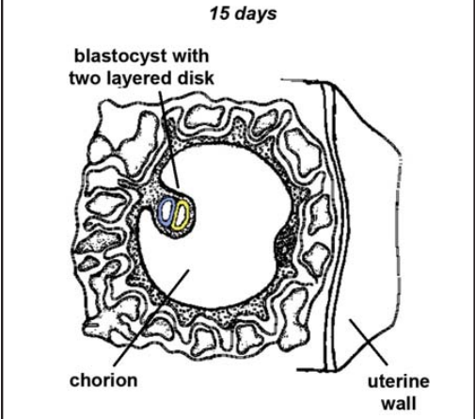
Fig.1.1 Blastocyst suspended in the chorionic cavity. The two-layered disk is formed by the epiblast ( blue) and the hypoblast ( yellow). (From Larsen WJ. Human Embryology. 2nd ed. Edinburgh, Scotland: Churchill Livingstone; 1998. Reprinted by permission).

Gastrulation, which occurs during the third week of gestation, is the process that transforms the two-layered embryonic disk into a three-layered structure, or germ layer, made of ectoderm, mesoderm, and endoderm[⁴]. During the third week of gestation, a definite notochord forms in the mesoderm between the ectoderm and endoderm. It is represented by a longitudinal tube of cells with a virtual central canal, which is located in the center of the embryonic disk along its major axis. (The term disk is used for ease of understanding. In this discussion, it indicates the relatively flat, round structure of the initial germ layer, even though a major axis, and thus a rather oval shape and loss of the flatness develops with cranio-caudal di̥fferentiation and further development).On both sides of the notochord, the mesoderm di̥fferentiates into three main areas: the paraxial, intermediate, and lateral mesoderms. The paraxial mesoderm divides on either side of the notochord into 42 to 44 pairs of somites (specialized cell accumulations). Development of the somites occurs in a craniocaudal fashion, and the number of somites can be used to estimate embryonic age. The first somites, and thus the cranial most, appear in the third week of gestation, and the most caudal and last ones will have formed by the end of the fifth week.
The somites are the precursors of the occipital bone, the vertebrae, other bony structures of the thorax, and the associated musculature of these structures. Each somite di̥fferentiates into two parts: a sclerotome, which is located medially, next to the notochord, and a dermomyotome, located laterally. The cells of the sclerotome are responsible for the formation of the bone, and the dermomyotomes form muscle cells and the overlying dermis of the skin. In the meantime, between the second and third weeks of gestation, and parallel to the formation of the notochord and the somites, the ectoderm above the notochord thickens and di̥fferentiates into neural ectoderm. By the end of the third week of gestation, the neural tube will have formed from this neural ectoderm and will overlay the notochord, suspended in the mesodermal layer. This process is called neurulation . The ectoderm from which the neural tube derived will have re-formed a continuous layer above the neural tube. The third week of gestation is a crucial period for the formation of the CVJ and vertebral column because three important processes take place contemporaneously definite formation of the notochord, formation and closure of the neural tube lying right above it, and formation and progressive appearance of the paired somites on either side of the notochord and neural
Tube(Fig 1.2).
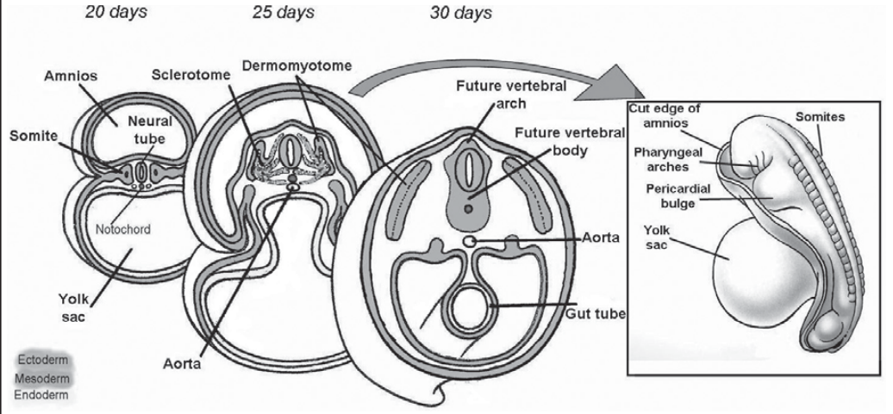
Fig 1.2 At 20 days, the epiblast and hypoblast have given rise to the mesoderm, the notochord, and the neural tube and transformed themselves into ectoderm and endoderm, respectively. At 25 days, the somites divide into sclerotomes and dermomyotomes, with the former migrating around the notochord and the neural tube to give rise to the vertebral column, with the latter becoming the paraspinal muscular apparatus. At 30 days, this division is largely completed. (FromLarsen WJ. Human Embryology. 2nd ed. Edinburgh, Scotland: Churchill Livingstone; 1998. Reprinted with permission).

Yet another event takes place in the third week of gestation that ḁffects the somites as they progressively appear and di̥fferentiate into sclerotomes and dermomyotomes: segmentation, which characterizes the membranous stage of development and demarcates the division between the skull and vertebral column[⁵].

1.1.2.Segmentation

As already mentioned, the somites di̥fferentiate into a medial part, the sclerotomes, and a lateral part, the dermomyotomes. Subsequently, the sclerotomes migrate medially and surround the notochord and the neural tube, forming a continuous mesodermal sheath and giving rise to a membranous basioccipital bone cranially and a membranous vertebral column below. The dermomyotomes will develop into the cervical musculature and overlying skin in the region. Sclerotomes 1 to 5 form the basioccipital elements of the skull. Sclerotomes 1 to 4 give rise to the basioccipital (midline segment that lies just ahead of the foramen magnum), exoccipital (lateral margins of the foramen magnum and superior part of the occipital condyles and jugular tubercles), and supraoccipital (posterior boundary of the foramen magnum) centers. Sclerotome 5 is highly specialized because it is the first one to form a motion segment and starts the process of segmentation. Segmentation of a sclerotome is a process in which proliferation leads to a more loosely packed cellular area in the cranial half of the sclerotome and a more densely packed area in its caudal half. As segmentation progresses, the loose cranial part and the dense caudal part will eventually separate, and the dense caudal part of one sclerotome will fuse with the loose cranial part of the one below. The splitting, and thus segmentation, of a sclerotome occurs in the area in which the future spinal nerve will transit.
In subaxial spinal development, the intervertebral disk develops, around and including the notochord, in the gap created by the segmentation of a sclerotome into cranial and caudal parts. The process can therefore be described in the following way. Division of a sclerotome into cranial and caudal parts at the passage point of the developing spinal nerve leads to formation of a disk in the gap created by fusion of the caudal half of the sclerotome with the cranial half of the following one, forming a vertebra. This cranial half of the following sclerotome was created through division from its inferior half. A disk will form in the gap, perpetuating this process caudally ( Fig. 1.3 ).
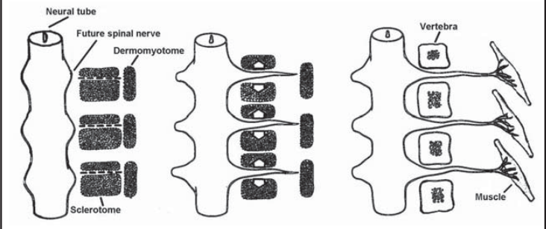
Fig.1.3 Illustration of the segmentation process of the sclerotomes once they have migrated around the neural tube and the notochord. (From Larsen WJ. Human Embryology. 2nd ed. Edinburgh, Scotland: Churchill Livingstone; 1998. Reprinted with permission.)

It is important to focus on this process because it takes place in the same regular fashion at the CVJ, even though it leads to a very particular expression[⁶]. As stated previously, sclerotome 5 plays a key role, because it starts segmentation. Sclerotomes 1 to 4 do not undergo segmentation and, by simply fusing one with the other, give rise to the occipital bone. The fifth sclerotome, however, will divide. Its loose cranial half will fuse with sclerotome 4 and give rise to the most caudal part of the occipital condyles and foramen magnum. Its dense caudal half will give rise to the cranial part of the atlas and the tip of the axis odontoid process. It is exactly at this point and in this particular moment of embryological development that the CVJ is formed, by segmentation of sclerotome 5.According to the previously described regular subaxial development of vertebrae and disks, its hould be expected that a disk forms in the gap created by the segmentation of the fifth sclerotome into cranial and caudal parts. Obviously, there is no disk between the occiput and the atlas, but given the fact that the apical ligament has been found to contain notochordal tissue, it can be regarded as a rudimentary intervertebral disk, along with the rest of the ligamentous apparatus[⁷]. In sclerotome 6, segmentation gives rise to a cranial half that forms the caudal part of the atlas and the odontoid process of the axis; the caudal half will form the cranial half of the body of the axis, and the cranial half of sclerotome 7 after segmentation will form the caudal half of the axis.The CVJ is thereby completed ( Fig. 1.4 ).
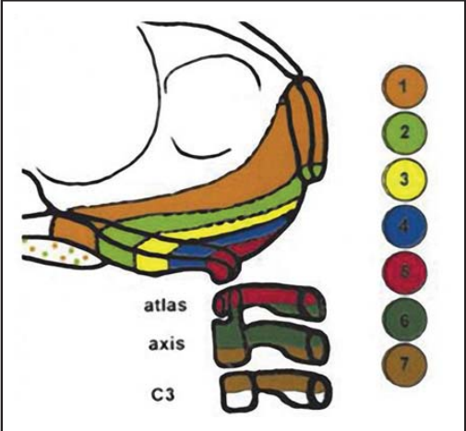
Fig.1.4 Illustration of the segmentation process in an avian embryo, showing which structures of the occipital bone and cervical spine arise from sclerotomes 1 to 7. (From Huang R, Qixia Z, Patel K, Wilting J, Christ B. Contribution of single somites to the skeleton and muscles of the occipital and cervical regions in avian embryos. Anat Embryol 2000;202:375–383. Reprinted with permission).

It can thus be stated that segmentation gives rise in sclerotome 5 to the articulation between the occipital condyles and the atlas, in sclerotome 6 to the articulation between the atlas and the axis, and in sclerotome 7 to the articulation between the axis and C3. Again, at the level of segmentation of sclerotome 6, an intervertebral disk could be expected, and indeed at birth a cartilaginous band between the odontoid process deriving from the cranial half of sclerotome 6 and the cranial part of the axis body deriving from the caudal half of sclerotome 6 represents a vestigial disk, referred to as a neural central or subdental synchondrosis . This line lies below the anatomical base of the odontoid and fuses through ossification between 3 and 6 years of age in most children, as discussed in the following section.

1.1.3.Vertebral Development

The processes described so far—notochord formation, somite formation, and sclerotome segmentation—as well as migration of the sclerotomic cells around the notochord and neural tube, occur in the membranous stage, which is mainly in the third week of gestation. This is the first stage of vertebral column development and also of occipital bone development, which is also somite dependent: the membranous vertebral column stage. Around the beginning of the fourth week, chondrification centers appear as two centers in each half of the vertebral body, on each side of the notochord, and a center for each half of the forming neural arch, on each side of the neural tube. As they are forming and joining, the notochordal cells from the vertebral bodies are squeezed into the disk spaces. These notochordal cells expand and become the nucleus pulposus of the disk at subaxial levels, whereas there is a di̥fferentiation of the noto
chord in the ligamentous complex between the occiput, the atlas, and the axis. At the level of the occipital bone, where no segmentation has occurred, the notochordal cells regress and do not give rise to any structure. During the later stage of cartilaginous formation of the spine, the four chondrification centers fuse into the cartilaginous vertebral body and arch. Around the seventh to eighth week of gestational age, the stage of ossification begins in the mid thoracic region, extending progressively both cranially and caudally[^{8,9}]. As far as the formation of the occipital bone is concerned, around the 10th to 12th week of gestation, heavy chondrification is observed in the basioccipital, exoccipital, and supraoccipital bones. Subsequently, one or two ossification centers appear in each of the regions. Fusion of the supraoccipital bone to the exoccipital bone occurs around 2 years of age, and not until 4 years of age will the basioccipital bone have fused with the exoccipital bone. Ossification is an ongoing process until early childhood for the vertebrae, extending until early adulthood for subaxial vertebrae. The time of appearance of the ossification centers of the atlas and the axis is slightly di̥fferent when compared with the subaxial vertebrae. Only the former will be discussed here. The atlas is usually ossified from three centers ( Fig. 1.5 ).
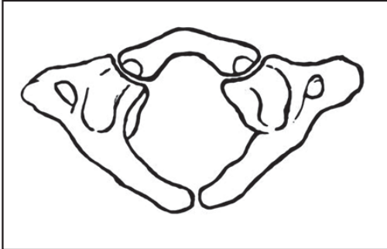
Fig. 1.5 The atlas and its structures derive from three ossification centers
One of these appears in each lateral mass around the seventh week of fetal life and extends backward; at birth, these portions of bone are separated from one another by a narrow interval filled with cartilage. Between the third and fourth years, they unite either directly or through the medium of a separate center developed in the cartilage. At birth, the anterior arch consists of cartilage; a separate center appears in this around the end of the first year and joins the lateral masses between the sixth and eighth years—the lines of union extend across the anterior portions of the superior articular facets. Occasionally, there is no separate center, and the anterior arch is formed by the forward extension and ultimate junction of the two lateral masses. Sometimes this arch is ossified from two centers, one on either side of the midline. The axis is ossified primarily from six centers ( Fig. 1.6 ).
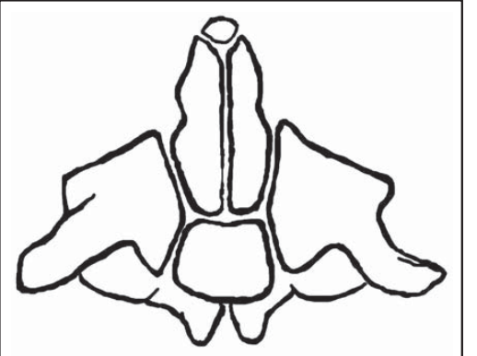
Fig.1.6 The axis and its structures derive from six ossification centers.

The body and vertebral arch are ossified in the same manner as the corresponding parts in the other vertebrae (i.e., one center for the body and two for the vertebral arch). The centers for the arch appear around the seventh or eighth week of fetal life and for the body about the fourth or fifth month. In the dens, which originally is a cartilaginous mass above the ossifying body, two centers make their appearance around the sixth month of fetal life; they are placed laterally and join before birth to form a conical bilobed mass deeply cleft above. The interval between the cleft and the summit of the dens at this stage continues to be formed by a wedge-shaped piece of cartilage. The base of the ossifying dens is separated from the body by a cartilaginous disk, which gradually becomes ossified at its circumference but remains cartilaginous in its center until advanced age ( Fig. 1.7 ).
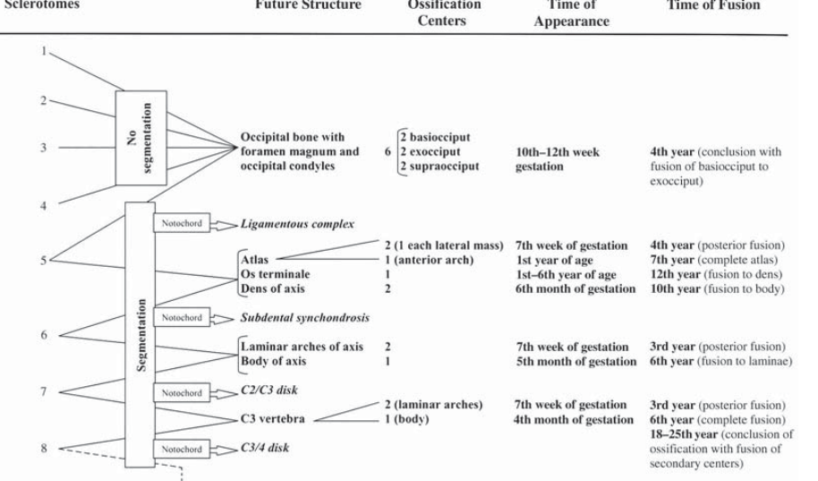
Fig.1.7 Synoptic graph illustrating the segmentation and maturation processes leading from sclerotomes to fully developed vertebral structures.

This is called the subdental synchondrosis , as discussed previously. It appears as a lucent line slightly below the plane of the superior border of the body of the axis and usually ossifies by 3 to 6 years of age, even though it may persist as a lucent line into adulthood. The sixth center of ossification of the axis is responsible for the tip of the dens. It may appear as early as the second year of life but usually does not develop until 5 or 6 years of age. It fuses with the body of the dens by 10 to 12 years of age although, rarely, it may not fuse and instead persist as a small ossicle (ossiculum terminale).

1.1.4.Clinical and Practical Implications

Knowledge of the various lines and times of fusion between the bony structures that compose the CVJ carries a utility that is of immediate intuition ( Fig. 1.7 ). Especially when dealing with the pediatric population, it proves very helpful to distinguish between normal and pathological. The widespread times of fusion of the single elements not only lead to peculiar lines of fusion within a specific vertebra, but also imply variations during the developmental process of the relationships between the vertebrae Understanding the process of segmentation and its
very regular proceeding, even at the level of the CVJ with its atypical vertebrae, helps to create a solid framework on the basis of which the normal development and derangement can be learned and memorized. The processes that regulate developmental steps in the complex region of the CVJ are surely multifactorial, with multiple links among them. This can be appreciated not only in the fact that an association of malformations can be observed in one patient (e.g., occipitalization of the atlas, odontoid malformations, or atlas arch abnormalities with basilar invagination), but also in the involvement of other organ system abnormalities, such as genitourinary tract or cardiovascular malformations (e.g., Klippel-Feil syndrome)[^{10,11}].
Ultimately, the importance of all these malformations lies in their dangerous potential to cause neurological compression. The available refined imaging technologies enable us to identify and pin point both bony malformation and neurological compromise at the CVJ with high accuracy. A thorough understanding of the developmental processes and derangements, however, is essential to selecting the most appropriate and at the same time physiological approach to CVJ pathology.
1.2.Relevant anatomy
1.2.1.Bony Structures

The posteromedial perspective of the CVJ is focused on the squamosal part of the occipital bone bordering the foramen magnum and on the posterior arch of C1 and C2 (Fig. 1.8).
The posterior surface of the squamosal part of the occipital bone in its medial portion has some relevant protuberances on which muscles of the neck attach: the external occipital protuberance (EOP), situated at the central part of the external surface; the superior nuchal line (SNL) and the inferior nuchal lines (INL) that radiate laterally from the protuberance; the posterior border of foramen magnum (FM); and the midline occipital crest, a vertical ridge that descends from the EOP to the midpoint of the posterior margin of the foramen magnum. The area below and between the superior and inferior nuchal lines is rough and irregular and serves as the site of attachment of numerous muscles. There is great variability in the position of the superior nuchal line, and therefore, it does not reflect the internal position of transverse sinus accurately. The relation of confluence of the sagittal sinus with the transverse sinus (torcular Herophili) to EOP is more consistent[^{13,15,18}]. On the posterior arch of the atlas is the median posterior tubercle, which substitutes the spinous process of any other vertebra. The posterior arch of the axis distinguishes by harboring the thickest lamina than on any other cervical vertebrae and a large spinous process serving as an attachment point of important suboccipital triangle muscles and the nuchal ligament[^{12,14,16}].

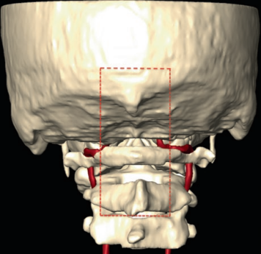
Fig. 1.8 3D anatomical model of the CVJ as seen from a posterior view. The area corresponding to the posteromedial perspective is highlighted with red dotted lines.E. d’Avella et al.

The posterolateral perspective of the CVJ is directed at the condylar part of the occipital bone and lateral masses of atlas and axis (Fig. 1.8). On the posterolateral external surface of the squamosal part of the occipital bone that extends from the EOP to the mastoid process of the temporal bone, an important bony landmark is the asterion. The asterion is located at the junction of the lambdoid, occipito-mastoid, and parieto-mastoid sutures and is commonly related to the lower half of the junction of the transverse and sigmoid sinuses. The superior and inferior nucal lines cross the posterolateral external surface of the occipital bone radiating laterally from the EOP and serves as the site of attachment of numerous muscles.[^{13,17}]

The condylar part of the occipital bone includes the occipital condyles and the condylar fossa, and it is situated at the sides of the foramen magnum. The occipital condyles protrude from the external surface of this part. They project downward along the lateral edges of the anterior half of the foramen magnum. The articular surfaces, which are ovoid with the long axis in the anteroposterior direction, are located on the lower-lateral margin of the condyles. They face downward and laterally to articulate with the superior facets of the atlas, which face upward and medially. The condylar fossa is a depression on the external surface of the occipital bone behind the condyle.[^{31,32}]

Lateral masses are the most voluminous bony parts of atlas forming four facet joints. The upper surface of each lateral mass has an oval concave facet that faces upward and medially and articulates with the occipital condyle that faces downward and laterally. The inferior surface of each lateral mass has a circular, flat, or slightly concave facet that faces downward, medially, and slightly backward, and it articulates with the superior articular facet of the axis. The lateral mass of the atlas on its upper-outer surface has a groove in which the V3 segment of the vertebral artery courses. The groove may be partly or fully converted into a foramen by a bridge of bone that arches backward from the posterior edge of the superior articular facet of the atlas to its posterior arch. The medial aspect of each lateral mass has a small tubercle for the attachment of the transverse ligament of the atlas[^{12,16}]. Each lateral mass of the axis consists of a pair of large oval facets that extend laterally from the vertebral body onto the adjoining parts of the pedicles and articulate with the inferior facets of the atlas superiorly and the superior facet of the third cervical vertebra inferiorly. The superior facets do not form an articular pillar with the inferior facets but are anterior to the latter.[^{16,31} ]
The anterolateral perspective of the CVJ is directed to the jugular foramen and transverse process of C1 and C2The jugular foramen (JF) is a canal-like aperture, which is formed by the combination of the most indented parts of the occipital and temporal bones. The jugular process consists of a quadrilateral plate of bone that extends laterally from the posterior half of the condyle to form the posterior border of the jugular foramen. It serves as a bridge between the condylar and squamosal portions of the occipital bone and forms the posteromedial wall of the foramen. The jugular process is penetrated by the hypoglossal canal. It articulates laterally with the jugular surface of the temporal bone. The jugular process also serves as the site of attachment of the rectus capitis lateralis muscle behind the jugular foramen. The upper surface of the jugular process at the junction of the basilar and condylar parts of the occipital bone presents an oval prominence, the jugular tubercle. It is situated above the hypoglossal canal and medial to the lower half of the intracranial end of the jugular foramen.[^{27,30}]
The transverse foramen of the atlas, which transmits the vertebral artery, is situated between the lateral mass and the transverse process. The transverse process of the atlas projects in the area between the mastoid process and the angle of the mandible, further lateral than the transverse processes on the adjacent cervical vertebrae. It has an apex that gives attachment to several muscles: the rectus capitis lateralis arises from the anterior portion; the superior oblique arises from the posterior portion of the upper surface of the transverse process; the inferior oblique muscle inserts on the lateral tip of the transverse process; the levator scapulae, splenius
cervicis, and the scalenus medius attach to the inferior and lateral surface of the transverse process . The transverse processes of the axis are small. Each transverse foramen faces supero-laterally, thus permitting the lateral deviation of the vertebral artery as it passes up to the more widely separated transverse foramina in the atlas [¹⁶].The anteromedial perspective of the CVJ provides exposure of the clival portion of occipital bone, anterior border of foramen magnum, anterior arch of C1, and the odontoid process (Fig. 1.9).

The clivus, or basilar part of the occipital bone, is a thick quadrangular plate of bone that extends forward and upward, at an angle of about 45° from the foramen magnum. It joins the sphenoid bone at the spheno-occipital synchondrosis just below the dorsum sellae. The clivus is separated on each side from the petrous part of the temporal bone by the petroclival fissure. This fissure has the inferior petrosal sinus on its upper surface and ends posteriorly at the jugular foramen. Clivus is divided into three parts: superior, middle, and inferior. The superior portion is located above the level of the sellar floor; the middle portion extends from the sellar level to the level of sphenoid floor; and the inferior portion from the sphenoid floor to the foramen magnum. On the inferior surface of the basilar part, in front of the foramen magnum, a small elevation, the pharyngeal tubercle, gives attachment to the fibrous raphe of the pharynx .
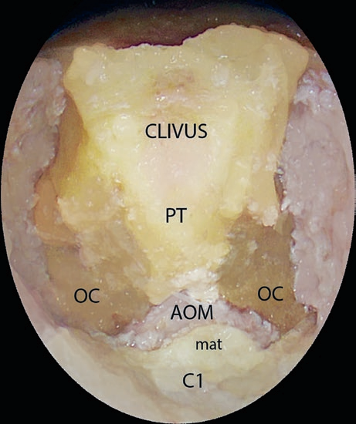

Fig 1.9 Endoscopic endonasal exposure of the anteromedial aspect of the CVJ.OM anterior occipital membrane; C1 atlas; mat middle anterior tubercle; OC occipital condyle; PT pharyngeal tubercle.
The clivus, or basilar part of the occipital bone, is a thick quadrangular plate of bone that extends forward and upward, at an angle of about 45° from the foramen magnum. On the inferior surface of the basilar part, in front of the foramen magnum, a small elevation, the pharyngeal tubercle, gives attachment to the fibrous raphe of the pharynx. The anterior arch of the atlas is short and convexed forward and has a median anterior tubercle. The anterior atlanto-occipital membrane is a thin structure that attaches the anterior aspect of the atlas to theanterior rim of the foramen magnum. It is located just posterior to the pre-vertebral muscles of the neck.
The atlas lacks a vertebral body, whose usual position is occupied by the odontoid process of the axis. The anterior arch is short and convexed forward and has a median anterior tubercle. The internal wall of the anterior arch is in contact with odontoid process forming a facet (fovea dentis). It is the widest cervical vertebra, with its anterior arch approximately half as long as its posterior arch . The dens of the axis, or odontoid process (dens), projects upward from the body of vertebra. The dens has a pointed apex, has a flattened side where the alar ligaments are attached, and is grooved at the base of its posterior surface where the transverse ligament of the atlas passes .[^{12,14}]

1.2.2.Muscular Structures

The trapezius is the most superficial muscle that is encountered when exploring the CVJ through a posteromedial corridor. It extends from the medial half of the SNL, the EOP, and the spinous processes of the cervical and thoracic vertebrae and converges on the shoulder to attach to the scapula and the lateral third of the clavicle. In a deeper layer, the splenius capitis is exposed in its medial half running to the spinous processes of the lower cervical and upper thoracic vertebrae. Deep to the splenius capitis, the semispinalis capitis begins medially at the midline occipital crest in the area between the superior and inferior nuchal lines and attaches below to the upper thoracic and lower cervical vertebrae (Fig. 1.10). In the next layer, along the posteromedial corridor, the rectus capitis posterior minor can be seen extending from the medial part and below the inferior nuchal line to the tubercle of the posterior arch of the atlas[^{15,17,19,20} ].
In the midline, the nuchal ligament forms a septation dividing the posterior neck muscles on left and right sides. Moreover, some of these muscles attach medially to this structure. The nuchal ligament extends from the spinous process of the cervical vertebrae to the EOP [²²].

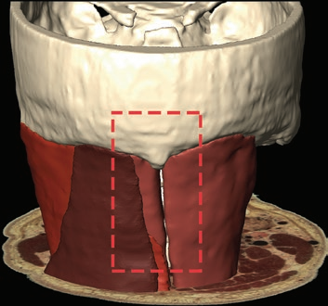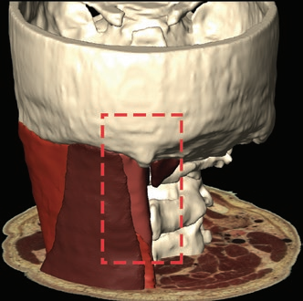
Fig. 1.10 3D model of the muscular layers visible through a posteromedial perspective to the CVJ. The anatomical area of interest is limited by the red dotted lines.On the right picture the superficial layer is represented by the trapezius muscle (dark brown), splenius capitis muscle (dark orange), and semispinalis capitis (light brown). On the right picture, trapezius and splenius capitis muscles have been removed, revealing the semispinalis capitis muscle.On the left picture the deep muscular layer is represented by rectus capitis posterior minor muscles (dark brown), exposed after the removal of the superficial layer muscles.
The most superficial layer of muscles of the CVJ that is encountered through a posterolateral perspective is formed by the sternocleidomastoid that passes obliquely downward across the side of the neck from the lateral half of the superior nuchal line and mastoid process to the upper part of the sternum and the adjacent part of the clavicle. The splenius capitis in its lateral half is partially covered by the sternocleidomastoid. It extends from the lateral third of the superior nuchal line medially to the spinous processes of the lower cervical and upper thoracic vertebrae. Deep to the splenius capitis and sternocleidomastoid are the semispinalis capitis beginning medially at the midline occipital crest and extending laterally to the occipito mastoid junction in the area between the superior and inferior nuchal lines and the longissimus capitis muscle, which attaches above to the posterior margin of the mastoid process. Both of these muscles attach below to the upper thoracic and lower cervical vertebrae (Fig. 1.11).The occipital artery is also exposed together with the superficial and deep muscles in this region. It courses medially related to the longissimus capitis and semispinalis capitis just below the superior nuchal line to ascend in the superficial fascia of the posterior scalp[¹⁵]. The great occipital nerve ascends with the occipital artery and supplies the scalp as far forward as the vertex and occasionally the back of the ear. It ascends obliquely between the inferior oblique and the semispinalis capitis muscles and pierces the latter and the trapezius muscle near their attachments to the occipital bone[²⁸]. In the next layer, the muscles bounding the suboccipital triangle are covered by the semispinalis capitis medially and by the splenius capitis laterally . The superior oblique muscle extends from the area lateral to the semispinalis capitis between the superior and inferior nuchal lines to the transverse process of the atlas. The inferior oblique muscle extends from the spinous process of the axis to the transverse process of the atlas. The rectus capitis posterior major extends from and below the lateral part of the inferior nuchal line to the spine of the axis. The triangle deep to these muscles is covered by a layer of dense fibro-fatty tissue. The structures in the triangle are the V3 segment of the vertebral artery on the posterior arch of the atlas and the first cervical nerve .[^{21,28}]
a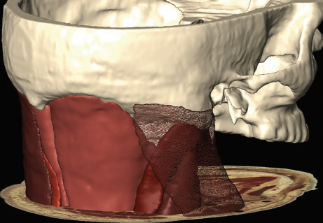b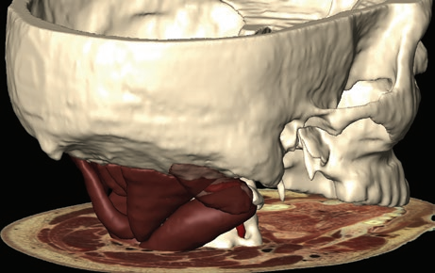
Fig.1.11 Muscular structures visualized through a posterolateral perspective of the CVJ are represented in a 3D
anatomical model. The superficial layer (a) with the transparent sternocleidomastoid and the muscles bounding the
suboccipital triangle (b) are reconstructed
The sternocleidomastoid muscle that passes obliquely downward from the lateral half of the superior nuchal line and mastoid process divides the side of the neck into an anterior triangle and a posterior triangle. The anterior triangle corresponds to the anterolateral aspect of the CVJ. It is bounded posteriorly by the anterior border of the sternocleidomastoid, laterally by the mandible and parotid gland, superiorly by the region of the jugular foramen and the mastoid process and anteriorly by the median line of the neck. In the fatty pad situated deep to the sternocleidomastoid runs the accessory nerve that supplies the muscle. In a deeper layer the posterior belly of the digastric muscle arises in the digastric groove located medial to the mastoid process and the longissimus capitis[¹⁴]. Reflecting the digastric muscle exposes the transverse process of the atlas, which is covered by the attachments of numerous muscles, including the superior and inferior obliques, which form the upper and lower margins of the suboccipital triangle.(Figs.1.12)
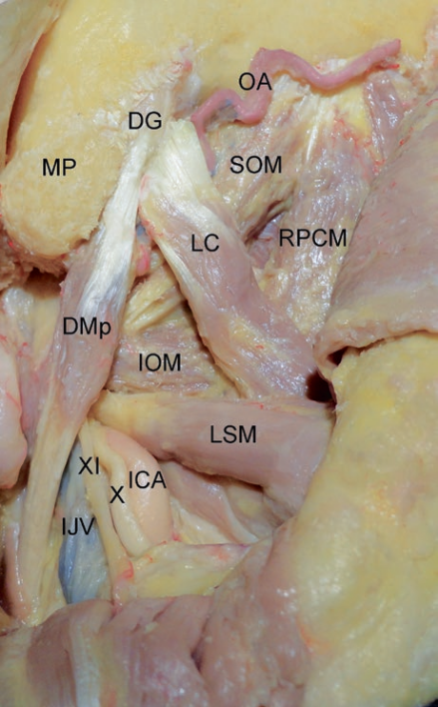
Fig 1.12 DG digastric groove; DMp posterior belly of digastric muscle; ICA internal carotid artery; IJV internal jugular vein; IOM inferior oblique muscle; LC longissimus capitis muscle; LSM levator scapulae muscle; MP mastoid process; OA occipital artery; RCPM rectus capitis posterior major muscle; SOM superior oblique muscle; X vagal nerve; XI accessory nerve.
The rectuscapitis lateralis muscle is the muscle most intimately related to the jugular foramen. It is considered together with the anterior vertebral muscles. It extends vertically behind the internal jugular vein from the transverse process of the atlas to the jugular process of the occipital bone.
The anterior vertebral muscles insert on the clival part of the occipital bone anterior to the foramen magnum. The longus colli is located on the anterior aspect of the cervical spine and consists of three portions. The superior oblique portion originates from the anterior tubercle of the transverse processes of the third through fifth cervical vertebrae and inserts on the tubercle of the anterior arch of the atlas; the inferior oblique and vertical portions extend from the fifth cervical vertebra downward to the third thoracic vertebra. The longus capitis originates from tendinous slips from the anterior tubercles of the transverse processes of the third through sixth cervical vertebrae, rising to insert on the basilar portion of the occipital bone. It is supplied by the anterior ramus of first through the third cervical spinal nerves. The rectus capitis anterior,located just deep to the superior aspect of the longus capitis, originates from the anterior surface of the lateral mass and the root of the transverse process of C1. It inserts on the foramen magnum anteriorly and on the basilar portion of the occipital bone. The rectus capitis lateralis has already been described as related to the jugular foramen . The anterior vertebral muscles are covered by the basipharyngeal fascia and on the midline by the median raphe. Median raphe is a thick band of connective tissue, which is attached to pharyngeal tubercle in the midline at clivus and continues below as anterior longitudinal ligament .

1.2.3.Extradural Structures

The posterior border of the foramen magnum and the upper border of the posterior arch of the atlas are connected by the posterior atlanto-occipital membrane (PAOM)that runs adjacent to the rectus capitis posterior minor posteriorly and the dura mater anteriorly. Connection orinterdigitation of the PAOM with both the rectus capitis posterior minor muscles and the spinaldura mater can be observed. The PAOM is continuous inferiorly with a thin membrane named the posterior atlanto-axial membrane, which is attached above to the lowerborder of the posterior arch of the atlas and below to the upper edges of the laminae of the axis, in series with the ligamentum flavum [²³]. The posterior opening of the FM is wider posteriorly than anteriorly and transmits the medulla (Fig. 1.13). The venous channels in the dura mater surrounding the foramen magnum in its posteromedial aspect are the marginal sinus and the occipital sinus. The marginal sinus is located between the layers of the dura in the rim of the foramen magnum. It communicates posteriorly with the occipital sinus. The occipital sinus courses in the cerebellar falx [^{20,24}].
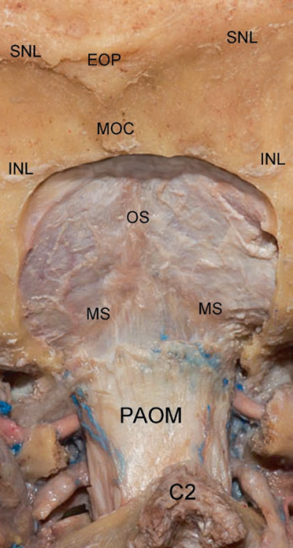
Fig. 1.13 Posteromedial perspective of the CVJ: C2 spinous process of the axis; INL inferior nuchal line; RCPm rectus capitis posterior minor muscle; SCM semispinalis cervicis muscle; MOC middle occipital crest; MS marginal sinus; OS occipital sinus; PAOM posterior atlanto-occipital membrane; SNL superior nuchal line .
Through a posterolateral perspective, the segment of the vertebral artery extending from the transverse foramen of C2 to its entrance to the dura is exposed (V3).At the level of the intervertebral foramen dorsal and ventral cervical nerves, roots unite to form the spinal nerve. At the same level, the neurons of the dorsal roots collect to form ganglia. The ganglion associated at the first cervical dorsal root may be absent. The C1, C2, and C3 nerves, distal to the ganglion, divide into dorsal and ventral rami. The dorsal rami divide into medial and lateral branches that supply the skin and muscles of the posterior region of the neck. The C1 nerve, termed the suboccipital nerve, leaves the vertebral canal between the occipital bone and atlas and has a dorsal ramus that is larger than the ventral ramus. The dorsal ramus courses between the posterior arch of the atlas and the vertebral artery to reach the suboccipital triangle, where it sends branches to the rectus capitis posterior major and minor, superior and inferior oblique, and the semispinalis capitis, and occasionally has a cutaneous branch that accompanies the occipital artery to the scalp. The C1 ventral ramus courses between the posterior arch of the atlas and the vertebral artery and passes forward, lateral to the lateral mass of the atlas and medial to the vertebral artery, and supplies the rectus capitis lateralis. The C2 nerve emerges between the posterior arch of the atlas and the lamina of the axis where the spinal ganglion is located extradurally, medial to the inferior facet of C1 and the vertebral artery. Distal to the ganglion, the nerve divides into a larger dorsal and a smaller ventral ramus. After passing below and supplying the inferior oblique muscle, the dorsal ramus divides into a large medial and a small lateral branch. The medial branch forms the greater occipital nerve. The lateral branch sends filaments that innervate the splenius, longissimus, and semisplenius capitis and is often joined by the corresponding branch from the C3 nerve. The C2 ventral ramus courses between the vertebral arches and transverse processes of the atlas and axis and behind the vertebral artery[^{12,13,17}] Two branches of the C2 and C3 ventral rami, the lesser occipital and greater auricular nerves, curve around the posterior border and ascend on the sternocleidomastoid muscle to supply the skin behind the ear(Fig.1.14).
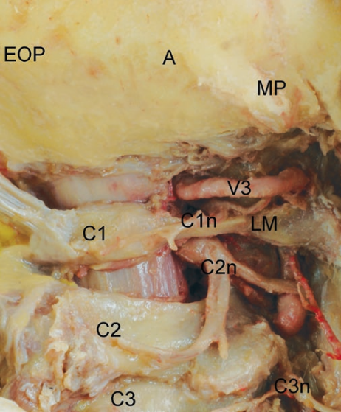
Fig.1.14 A asterion; C1 atlas; C1n suboccipital nerve; C2 axis; C2n second cervical nerve; C3 third cervical vertebra; third cervical nerve; EOP external occipital protuberance; LM lateral mass of the atlas; MP mastoid process; V3 third segment of the vertebral artery.

The condylar foramen is present in the condylar fossa posterior to the occipital condyle. It transmits the posterior condylar vein, which is an important emissary vein of the cranium. This vein connects the vertebral venous plexus with the sigmoid-jugular complex. The condylar foramen is one of the largest emissary foramina of the skull and the posterior condylar vein, which traverses it, forms an important alternative source of venous drainage when the venous flow into the sigmoid sinus-jugular complex is impeded.[^{29,31}]
The hypoglossal canal (HC), which transmits the hypoglossal nerve, is situated above the condyle and is directed forward and laterally from the posterior cranial fossa. The canal is surrounded superiorly by the jugular tubercle, supero-laterally by the jugular foramen, laterally by the sigmoid sinus, and inferiorly by the occipital condyle. The intracranial end of the HC is located approximately 5 mm above the junction of the posterior and middle third of the occipital condyle and appropriately 5 mm below the jugular tubercle. The extracranial end is located immediately above the junction of the anterior and middle third of the occipital condyle and medial to the jugular foramen. The HC is surrounded by cortical bone. It consists of the hypo
glossal nerve, a meningeal branch of the ascending pharyngeal artery, and the venous plexus of the hypoglossal canal, which communicates the basilar venous plexus with the marginal sinus that encircles the foramen magnum.[¹⁷]The hypoglossal nerve enters the canal as two groups of roots that merge just before exiting the canal (Fig,1.15).

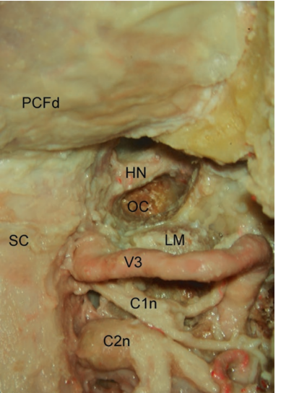
Fig 1.15 C1n first cervical nerve; C2n second cervical nerve; HN hypoglossal nerve; LM lateral mass of the atlas; OC occipital condyle; PCFd dura of the posterior cranial fossa; SC spinal cord; V3 third segment of the vertebral artery.
The sigmoid sinus borders the posterior cranial fossa laterally and descends along the sigmoid groove. It exits the cranium through the sigmoid part of the jugular foramen and descends anterolateral to the occipital condyle and anterior to the transverse process of the atlas .The endocranial surface of the jugular foramen is generally divided into three intra jugular compartments: two venous and a neural compartment . The neural and vascular compartments are generally separated by a bone projection called the intra jugular process. The larger posterolateral venous compartment, the sigmoid compartment, receives the flow of the sigmoid sinus.The sigmoid sinus drains into the internal jugular vein at the jugular bulb. The smaller anteromedial venous channel, the petrosal part, receives the drainage of the inferior petrosal sinus, besides receiving tributaries from the hypoglossal canal, petroclival fissure, and vertebral venous plexus. The neural part, through which the glossopharyngeal, vagus, and accessory nerves course, is located between the sigmoid and petrosal parts at the site of the intrajugular processes of the temporal and occipital bones, which are joined by a fibrous or osseous bridge. The dura over the neural part of the foramen has two characteristic perforations, a glossopharyngeal meatus, through which the glossopharyngeal nerve passes, and a vagal meatus, through which the vagus and accessory nerves pass. Along their exit from the jugular foramen, the glossopharyngeal, vagus, and accessory nerves penetrate the dura on the medial margin of the intrajugular process of the temporal bone to reach the medial wall of the internal jugular vein.
The glossopharyngeal nerve exits the jugular foramen and then turns forward, crossing the lateral surface of the internal carotid artery deep to the styloid process. At the external orifice of the jugular foramen, it gives rise to the tympanic branch (Jacobson’s nerve) that provides innervation to the parotid gland. At the level of the vagal meatus, the vagal nerve is joined by the accessory nerve and gives rise to the Arnold’s nerve, an auricular branch that join the facial nerve in the temporal bone. The vagal nerve exits the jugular foramen vertically, retaining an intimate relationship to the accessory nerve. At the level the two nerves exit the jugular foramen, they are located behind the glossopharyngeal nerve on the posteromedial wall of the internal jugular vein. As the vagal nerve passes lateral to the outer orifice of the hypoglossal canal, it is joined by the hypoglossal nerve medially. The accessory nerve exiting the jugular foramen descends obliquely laterally between the internal carotid artery and internal jugular vein and then backward across the lateral surface of the vein to reach its muscles. The hypoglossal nerve does not traverse the jugular foramen. However, it joins the nerves exiting the jugular foramen just below the skull and runs with them in the carotid sheath[^{29,30}]. The nerve exits
the inferolateral part of the hypoglossal canal and passes adjacent to the vagal nerve, descends between the internal carotid artery and the internal jugular vein to the level of the transverse process of the atlas, where it turns abruptly forward along the lateral surface of the internal carotid artery toward the tongue (Fig.1.16).
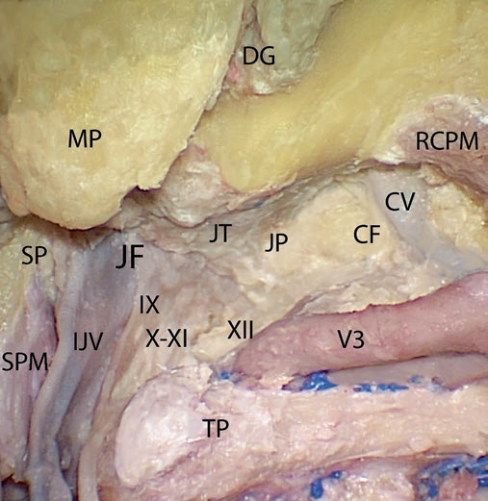
Fig .1.16 CF condylar fossa; CV condylar vein; DG digastric groove; IJV internal jugular vein; JF jugular foramen; JP jugular process; JT jugular tubercle; MP mastoid process; RCPM rectus capitis posterior major muscle; SP styloid process; SPM stylopharyngeus muscle; TP transverse process of the atlas; V3 third segment of the vertebral artery; IX glossopharyngeal nerve; X vagal nerve; XI accessory nerve; XII hypoglossal nerve.

The internal jugular vein is the most volumetric structure in the JF. The proximal dilated part is called the jugular bulb. Anteriorly the inferior petrosal sinus and posteriorly the sigmoid sinus are the venous structures that drain into the jugular bulb. The top of the jugular bulb may reach out the porus acusticus internus in the temporal bone. The internal jugular vein and its tributaries form the most important drainage system in the craniocervical area . The internal carotid artery passes, almost straightly upward, posterior to the external carotid artery and anteromedial to the internal jugular vein, to reach the carotid canal. At the level of the skull base, the internal jugular vein courses just posterior to the internal carotid artery, being separated from it by the carotid ridge. Between them, the glossopharyngeal nerve is located laterally and the vagus, accessory, and hypoglossal nerves medially [^{7, 28}]The external carotid artery ascends anterior to the internal carotid artery. Proximal to its terminal bifurcation into the maxillary and the superficial temporal arteries, it gives rise to the posterior branches that are related to the jugular foramen: the ascending pharyngeal artery, the occipital artery and the posterior auricular artery [^{1, 7}]. The occipital artery is the largest branch of the posterior group. It arises from the posterior surface of the external carotid artery at the level of the angle of the mandible and courses obliquely upward between the posterior belly of the digastric muscle and the internal jugular vein, to reach thearea posteromedial to the styloid process. At that point, it changes its course to posterior andlateral, passing posterior to the rectus capitis lateralis and then between the superior oblique and the posterior belly of the digastric where it courses in the occipital groove medial to the mastoid notch, in which the posterior belly of the digastric muscle arises. After exiting the area between the superior oblique muscle and the posterior belly of the digastric, it courses medially, being related to the longissimus capitis and semispinalis capitis. It courses medially behind the semispinalis capitis just below the superior nuchal line in the upper part of the posterior triangle to pass between the upper attachment of trapezius and the semispinalis capitis, where it pierces the attachment of the trapezius muscle to the superior nuchal line and ascends in the superficial fascia of the posterior scalp[¹³ ].The vertebral artery, above the transverse foramen of the axis, veers laterally to reach the transverse foramen of the atlas, which is situated further lateral than the transverse foramen of the axis (second segment of the vertebral artery, V2). The artery, after ascending through the transverse process of the atlas, is located on the medial side of the rectus capitis lateralis muscle. From here it turns medially behind the lateral mass of the atlas and the atlanto-occipital joint and is pressed into the groove on the upper surface of the posterior arch of the atlas (V3) .The two atlanto-occipital joints are true synovial joints. They contain synovial membrane and are covered by capsular ligaments. The atlas and the occipital bone are united anteriorly by the anterior atlanto-occipital membrane. The anterior atlanto-occipital membrane (AAO) is a thin structure that attaches the anterior aspect of the atlas to the anterior rim of the foramen magnum. It is located just posterior to the pre-vertebral muscles of the neck and serves as the anterior wall of the supra-odontoid space, which houses the alar and apical ligaments, as well as fat and veins (Fig. 1.17). The alar ligament attaches the lateral aspects of the odontoid process to the base of the skull on the medial aspect of the occipital condyles.
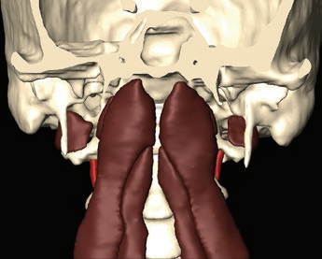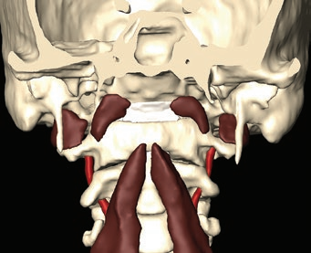
Fig. 1.17 On the upper picture The rectus capitis anterior, located just deep to the superior aspect of the longus capitis, originates from the anterior surface of the lateral mass and the root of the transverse process of C1.On the lower picture The rectus capitis lateralis extends vertically behind the internal jugular vein from the transverse process of the atlas to the jugular process of the occipital bone
.
The anterior vertebral muscles are covered by the basipharyngeal fascia and on the midline by the median raphe. Median raphe is a thick band of connective tissue, which is attached to pharyngeal tubercle in the midline at clivus and continues below as anterior longitudinal ligamentin intimate contact with the dura mater of the clivus posteriorly.The tectorial membrane firmly adhered to the cranial base and body of the axis, where it is continuous with the posterior longitudinal ligament, but not to the posterior odontoid process. The posterior longitudinal ligament is attached below to the posterior surface of the body of the axis, and above to the transverse part of the cruciform ligament and the clivus. In front, the atlas and axis are connected by the anterior longitudinal ligament, which is a wide band fixed above to the lower border of the anterior arch of the atlas and below to the front of the body of the axis .The basilar venous plexus is located between the layers of the dura mater on the upper clivus. It is formed by interconnecting venous channels that anastomose with the inferior petrosal sinuses laterally, the cavernous sinuses superiorly, and the marginal sinus and epidural venous plexus inferiorly . On the anteromedial aspect of the CVJ, at the level of the superior surface of the occipital condyle, the supracondylar groove corresponds to an area formed by the insertion of the rectus capitus anterior muscle, anterior atlanto-occipital membrane, and atlanto-occipital capsule joint. The hypoglossal canals are situated posterior and lateral to the supracondylar groove.

1.2.4.Intradural Structures
Through a posteromedial perspective, the medulla can be exposed, occupying the foramen magnum. The medulla blends indistinguishably into the spinal cord at a level arbitrarily set to be at the upper limit of the dorsal and ventral rootlets forming the first cervical nerve.Posteromedially, the spinal cord is divided by the posteromedian sulcus into symmetrical halves. Each half is occupied by the posterior funiculus. At the upper cervical level, the surface of the posterior funiculus is divided by another shallow longitudinal furrow, the posterior intermediate sulcus, into the fasciculus gracilis medially and the fasciculus cuneatus laterally. Superiorly, the posterior surface of the medulla is composed in the midline of the inferior half of the fourth ventricle and laterally by the inferior cerebellar peduncles[^{13.19}]. Inferiorly the posterior surface is composed of the gracile fasciculus and tubercle medially, and the cuneate fasciculus and tubercle laterally .(Fig 1.18)
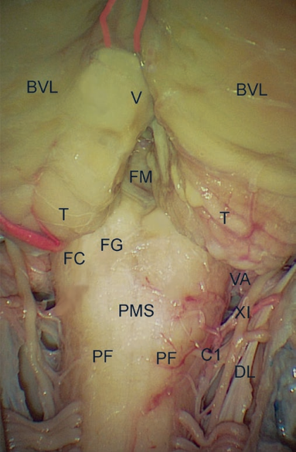
Fig. 1.18BVL biventral lobule of the cerebellar hemisphere; C1 dorsal root of the first cervical nerve; DL dentate ligament; FC fasciculus cuneatus; FG fasciculus gracilis; FM foramen of Magendie; PF posterior funiculus; PMS posteromedial sulcus; T tonsil; V vermis; VA vertebral artery; XI accessory nerve.
The posteromedial aspect of the cerebellum related to the foramen magnum consists in the lower part of the hemispheres (formed by the tonsils and the biventral lobules) and the lower part of the vermis (formed by the nodule, uvula, and pyramid). The cerebellar surface above the posterior part of the foramen magnum has a deep vertical depression, the posterior cerebellar incisura, which contains the falx cerebelli and extends inferiorly toward the foramen magnum. The vermis is folded into and forms the cortical surface within this incisura. The vermian surface within the incisura is composed of the pyramid in its upper half and of the uvula that projects downward between the tonsils. Inferiorly, the posterior cerebellar incisura is continuous with the vallecula cerebelli, an opening between the tonsils that extends upward through the foramen of Magendie into the fourth ventricle .Each tonsil is an ovoid structure that is attached along its superolateral border to the remainder of the cerebellum. The superior pole faces the inferior half of the roof of the fourth ventricle. The anterior surface of each tonsil faces and is separated from the posterior surface of the medulla by the cerebello-medullary fissure. This fissure extends superiorly to the level of the roof of the fourth ventricle and the lateral recesses of the fourth ventricle. The dorsal wall of the fissure is formed by the uvula in the midline and the tonsils and biventral lobules laterally. The ventral wall is formed by the inferior medullary velum and tela choroidea. The inferior medullary velum is a thin sheet of neural tissue that blends into the ventricular surface of the nodule medially and stretches laterally across the superior pole of the tonsil. The tela choroidea, from which the choroid plexus projects, forms the lowest part of the roof of the fourth ventricle.[^{25,26} ]
The vertebral artery in its third segment (V3) pierces the PAOM, then dura mater, to enter the posterior fossa. As the artery pierces the dura, it is encased in a fibrous tunnel that binds the posterior spinal artery, dentate ligament, first cervical nerve, and the spinal accessory nerve to it. The C1 nerve root passes through the dura mater on the lower surface of the vertebral artery. The posterior spinal artery arises from the posteromedial surface of V3 initial just outside or inside the dura mater. In the subarachnoid space, it courses medially between the accessory nerve and the dentate ligament. At the lower medulla, it divides into an ascending branch that supplies the gracile and cuneate tubercles, the rootlets of the accessory nerve, and the choroid plexus near the foramen of Magendie, and a descending branch that supplies the superficial part of the dorsal half of the cervical spinal cord. It anastomoses with the posterior branches of the radicular arteries that enter the vertebral foramen at lower levels. The descending branch gives rise to collateral branches, which course medially across the posterior surface of the spinal cord and join to form an artery that course in the posterior midline.[²⁷]. The posterior meningeal artery arises from the posterosuperior surface of the vertebral artery. Its origin may be intra- or extradural and supplies the dura mater of the posterior and posterolateral part of the posterior cranial fossa[ ¹⁵]. The median posterior spinal vein, which courses along the posteromedian spinal sulcus, is continuous above with the main vein on the posterior surface of the medulla and the median posterior medullary vein, which courses along the posteromedian medullary sulcus. The transverse medullary and transverse spinal veins cross the medulla and spinal cord at various levels, interconnecting the major longitudinal channels[²⁷]. The accessory nerve is the only cranial nerve that passes through the foramen magnum between the dentate ligament and the dorsal spinal roots. The main caudal trunk from the spinal cord is exposed through a posteromedial perspective. There are frequently communications between the C1 nerve root and the spinal accessory Nerve.The dentate ligament is a white fibrous sheet that is attached to the spinal cord medially and to the dura mater laterally. Its rostral attachment is at the level of the foramen magnum where the vertebral artery pierces the dura. The ligament courses behind the accessory nerve at that level [¹⁵].The posterolateral perspective at the CVJ allows for intradural exposure of the cerebellomedullary cistern and posterior spinal cistern. The cerebello-medullary cistern extends from the dorsal margin of the inferior olive around the dorsolateral medulla to the biventral lobule of the cerebellum. The glossopharyngeal (IX) and vagal nerves (X) and the medullary portion of the accessory nerve (XI) arise within and course through this cistern to reach the jugular foramen . The intradural segment of the vertebral artery (V4) can be divided into alateralmedullary segment and an anterior medullary segment. The V4 lateral medullary segment begins at the dural foramen and passes anterior and superior along the lateral medullary surface to terminate at the pre-olivary sulcus. The posterior inferior cerebellar artery (PICA) enters this cistern after originating from the fourth segment (V4) of the vertebral artery intradurally. In the cerebello-medullary cistern, the PICA passes dorsally between the rootlets of the IX, X, and XI cranial nerves and pursues a posterior course around the medulla (Fig.1.19).The lateral surface of the medulla is formed predominantly by the inferior olives. The glossopharyngeal, vagus, and accessory nerves arise from the medulla as a line of rootlets situated along the posterior edge of the inferior olive in the post-olivary sulcus. The only location where the glossopharyngeal nerve may consistently be distinguished from the vagal nerve is just proximal to a dural septum, which separates these nerves as they penetrate the dura to enter the jugular foramen. The hypoglossal nerve arises as a line of rootlets that exit the brainstem along the anterior margin of the lower olive in the pre-olivary sulcus, a groove between the olive and medullary pyramid. The rootlets of the XII pass behind the vertebral artery to reach the hypoglossal canal. The vertebral artery may stretch the hypoglossal rootlets posteriorly over its dorsal surface. The accessory nerve in the cranial fossa is composed of one main trunk from the spinal cord and three to six small rootlets that emerge from the medulla. The nerve joins the vagus nerve entering the jugular foramen . At the level of the spinal cord, the posterior lateral sulcus is situated along the line where the dorsal roots enter the spinal cord. Each dorsal root is composed of a series of six to eight rootlets that fan out to enter the posterolateral surfaces of the spinal cord. The dorsal roots of the first two cervical nerves pass posterior to the dentate ligament and accessory nerve . The lateral posterior spinal vein, which courses along the line of origin of the dorsal roots in the posterior lateral spinal sulcus, is continuous above with the lateral medullary vein that courses along the retro-olivary sulcus, dorsal to the olive.

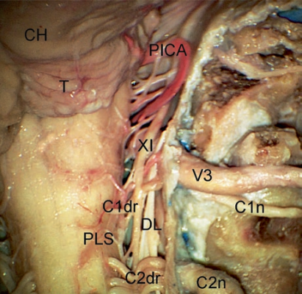
Fig .1.19 CH cerebellar hemisphere; C1dr dorsal root of the first cervical nerve; C1n first cervical nerve; C2dr dorsal roots of the second cervical nerve; C2n second cervical nerve; DL dentate ligament; PICA posterior inferior cerebellar artery; PLS posterior lateral sulcus; T tonsil; V3 third segment of the vertebral artery; XI accessory nerve.

The intradural anteromedial aspect of the CVJ corresponds to the medullary pyramids, which face the clivus, the anterior edge of the foramen magnum, and the rostral part of the odontoid process. The anterior median sulcus divides the medulla between the pyramids and is continuous caudally with the anterior median fissure of the spinal cord. The rootlets forming the hypoglossal nerve, the glossopharyngeal, vagus, and accessory nerves run laterally from the lateral surface of the brainstem in the cerebello-medullary cistern (Fig.1.20). The anterior medullary segment of the vertebral artery (V4) begins at the preolivary sulcus, courses in front of, or between, the hypoglossal rootlets, and crosses the pyramid to join with the other vertebral artery at or near the pontomedullary sulcus to form the basilar artery. Branch of the anterior medullary segment is the anterior spinal artery. The anterior spinal artery is formed by the union of the paired anterior ventral spinal arteries near the origin of the basilar artery.
The artery descends through the foramen magnum on the anterior surface of the medulla andthe spinal cord in or near the anteromedian fissure. On the medulla, it supplies the pyramids and their decussation, the medial lemniscus, the interolivary bundles, the hypoglossal nuclei and nerves, and the posterior longitudinal fasciculus. It anastomoses with the anterior branches of the radicular arteries entering the cervical foramina[^{12.13}].The median anterior spinal vein, that courses in the anteromedian spinal fissure deep to the anterior spinal artery, is continuous with the median anterior medullary vein that courses on the anteromedian sulcus of the medulla .

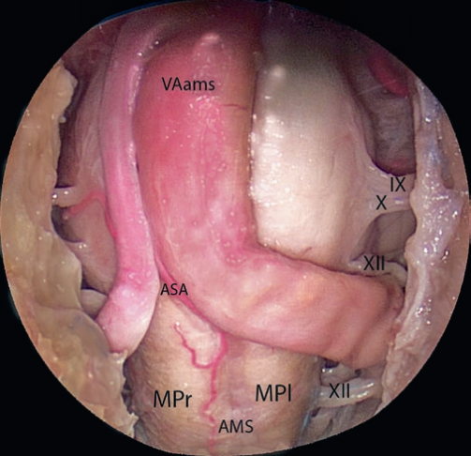
Fig. 1.20 Endoscopic endonasal exposure of the intradural anteromedial aspect of the CVJ.AMS anterior median sulcus; ASA anterior spinal artery; MPl left medullary pyramid; MPr right medullary pyramid; VAams vertebral artery anterior medullary segment; IX glossopharyngeal nerve; X vagal nerve; XII hypoglossal nerve.

1.2.5.Vertebral artery in relation to C1-C2 complex

The vertebral artery (V. A.) is anatomically divided into four portions from its origin to its intracranial junction with the controlateral V. A. (Fig.1. 21).
First Portion (V1)
This portion includes the proximal or ostial segment, from the artery origin to its entry into the bony transverse canal, which is usually at the level of C 6.

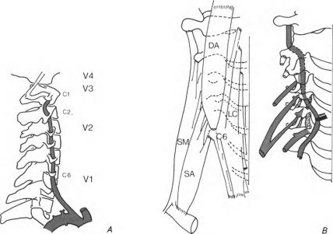

Fig. I. 21 Anatomical division of the cervical V. A. B) Anatomical relationship of the cervical V. A. Left: deep muscles covering anteriorly the V. A. LC Longus colli M. DA Anterior rectus M. SM, SA Scalenus M. Right: nerve roots merging posteriorly to the V. A. The transverse canal is opened at C5C6
Second Portion (V2)
This portion consists of the transverse segment from its entry at the C 6 level to the transverse foramen of C 2.
Third Portion (V3)
This portion is the suboccipital segment and extends from C 2 up to penetration of the dura meter at the foramen magnum. Transverse foramen of C 2: this forms a true canal with two different curves; the first in a horizontal plane on its inferior side (foramen entry) and the second, oblique, backward, and outward at its entry, becomes horizontal inside the foramen and again runs vertically after its exit. Between C 2 and C 1: the V. A. runs vertically up to the foramen of C 1, still surrounded by the same periosteal sheath as in the transverse portion, and covered by the levator scapulae and inferior oblique muscles. Transverse foramen of C 1: at this level, the V. A. bends backwards and inwards. The transverse foramen of C 1 is noticeably prolonged by a process much larger than at any other level. This serves as a very good surgical landmark. Groove above C 1: the artery runs around the lateral mass of the atlas in a marked by a small increase in the height of the posterior arch. At this point, the V . A. bends forward, upward and a little inward to reach the dura on the lateral aspect of the foramen magnum[³²]. In this portion, the periosteal sheath is reinforced laterally by the transverse horizontal groove above the posterior. Bony canal around the V. A. above the arch of C 1. The end of this groove is marked by a small increase in the height of the posterior arch. At this point, the V.A. bends forward, upward and a little inward to reach the dura on the lateral aspect of the foramen magnum. In this portion, the periosteal sheath is reinforced laterally by the transverse ligament and posteriorly by the retroglenoid ligament. These ligaments may be ossified, either on the external portion or over the entire length of the posterior groove. In the latter case, the groove becomes a completely osseous canal .

Fourth Portion (V4)
This intracranial segment extends from the foramen magnum to the junction of the V. A. with the controlateral V. A., forming the basilar trunk.
Structurally V. A. has a very thin wall in proportion to its size and when compared with arteries of similar diameter elsewhere in the body,The average diameter of the V. A. is 4.5 mm; for the right V. A. and 4.7 mm for the left V. A., as established by Francke et al. As is well known,the vertebral arteries are frequently asymmetric; the larger is called the dominant artery and the smaller controlateral one is called the minor artery. The minor V . A. is sometimes very small and does not participate in formation of the basilar trunk.. which seems to end at the posterior inferior cerebellar artery (P. 1. C. A.), does not fill the basilar trunk. The term hypoplastic V. A. usually refers to this type of minor V. A., but it supposes that a connection with the basilar trunk exists. The term atretic V. A. usually refers to a minor V. A. which does not inject the basilar trunk (Fig.1.22). Finally, one or both V. A. may be absent; in that case, they are frequently replaced by a persistant congenital anastomosis (Tsai et al., 1975).

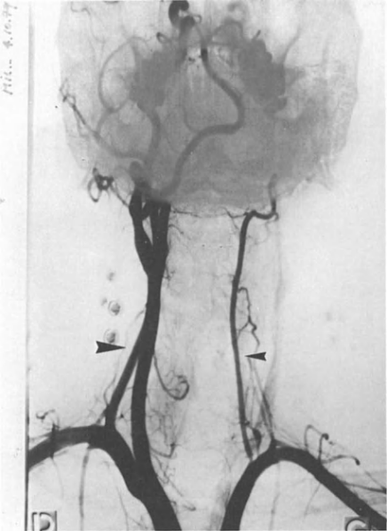
Fig. 1.22. Dominant V. A. on right side . Atretic V. A. ending at PICA and not filling the basilar trunk on left side .
Along its course, the V3 segment is subdivided into three portions. The vertical portion courses between the C2 and C1 transverse foramina. Its name comes from its course orientation when the head is considered in a neutral position. The horizontal portion follows the groove situated on the superior aspect of the posterior arch of the atlas. The junction between the vertical and horizontal portions forms a 90° angle in neutral position. The oblique portion prolongs the medial aspect of the horizontal portion toward the dura mater of the foramen magnum. Its course is oblique following the shape of the bone of the posterior arch of the atlas that forms a step at this level. Bone structures represent crucial landmarks during the exposure of the V3 segment.During a posterolateral approach (Fig.1.23 a,b), the VA is safely exposed at C1 by alateromedial subperiosteal dissection along the C1 posterior arch. This technique allows to localize safely the step formed by the bone and then the VA that runs just above it. During an anterolateral approach the C1 transverse process represents a crucial landmark that can be palpated 15 mm below the mastoid tip. Dividing the muscles that insert on it (the superior oblique, the rectus capitis lateralis, the inferior oblique, the levator scapulae, the splenius cervicis, and the scalenius medius [^{33,34}].

a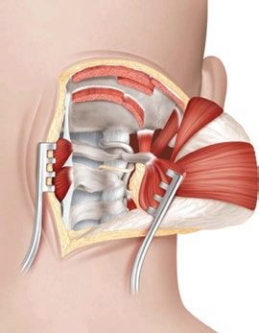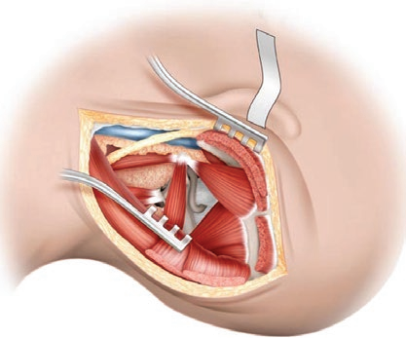b

Fig .1.23 Approaches to the vertebral artery V3 segment. (a) The posterolateral approach. (b) The anterolateral approach. (From George B, Bruneau M, Spetzler RF (eds). Pathology and surgery around the vertebral artery. Springer; 2011).

1.2.6.Lateral mass of atlas and axis
Both lateral mass fixation of the C1 and C2 vertebrae using the plate-and-screw method and transarticular screw fixation provide biomechanically stable unions in patients with atlantoaxial dislocation[^{34,36}]. Various groups, however, have indicated their concern about the safety of these techniques, considering the danger to the vertebral artery. To use these techniques optimally and safely, it is necessary for the surgeon to have exact anatomical information about the region in a three-dimensional perspective. Only a few reports in the literature describe the quantitative measurements of the craniovertebral region and the parameters appropriate for screw implantation. Most of these reports are based on radiological measurements 6–8 and deal with the dens and canal diameters. There are only isolated reports detailing quantitative measurements of the lateral masses of C1 and C2.[^{37,38}]The superior facet of the atlas is oval with a groove on either side. Less frequently, it is kidney-shaped, with the groove present on only one side of the facet. This facet is longer in its anteroposterior dimension (mean 20 mm) than in its transverse dimension (mean 11 mm) .Both superior and inferior facets of the atlas face medially toward the spinal canal. The inferior facet of the atlas is almost circular in most of the vertebrae without any significant di̥fference in the mean anteroposterior and transverse (mean 15 mm) dimensions[³⁵].The thickness of the inferior facet under the posterior arch of the atlas is on average 3.5 mm .The thickness of the posterior arch of the atlas separating the vertebral artery groove from the inferior facet is 4 mm ( Fig. 24.a,b).
The vertebral artery foramen is in the transverse process lateral to the lateral mass of the C1 vertebra. The groove for the vertebral artery on the superior surface of he posterior arch of the atlas is occasionally converted into a complete bony foramen.The distance from the midline to the medial most edge of the vertebral artery groove on the outer cortex of the posterior arch is on average 18 mm .[³⁸]

a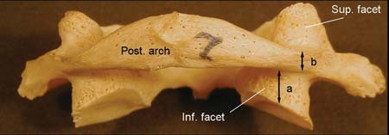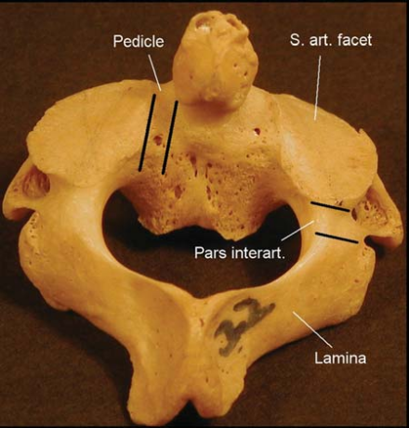b
Fig.1.24 a.b Posterior view for both C1 and C2 vertebrae.
The superior facet of the C2 vertebra di̥ffers from the facets of all other vertebrae in two important characteristics, making this region prone to vertebral artery injury during screw fixation. First, the superior facet of C2 is closer to the body when compared with facets of the other vertebrae, which are located in proximity to the lamina. Second, the vertebral artery foramen is present partially or completely in the inferior aspect of the superior facet of C2, whereas in the subaxial cervical vertebrae the vertebral artery foramen is located entirely within the transverse process and delimitates the anterior border of the vertebral pedicle[³⁹ ] .The course of the vertebral artery in relation to the inferior surface of the superior articular facet of C2 makes it susceptible to injury during transarticular and interarticular screw implantation techniques ( Figs.1.25 a,b) .
a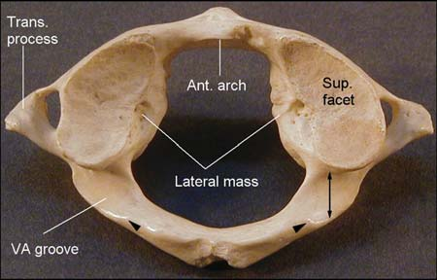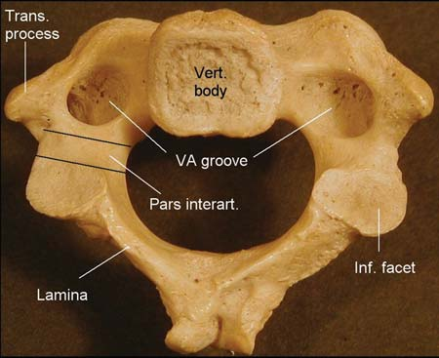b
Fig.1.25 a,b Superior view for C1 vertebra and inferior view for C2 vertebra.
The shape of the superior articular surface of the axis varies from oval to circular. It is convex in the sagittal plane and is directed laterally to articulate with the inferior facet of C1. The average depth of the vertebral artery groove on the inferior surface of the superior facet is 4 mm. the vertebral artery groove could extend in the superior facet up to its medial third, middle third or lateral third . The transverse thickness or the width of the pars interarticularis is 8 mm on average. The total length of the pars interarticularis is 15 mm. The angle of its projection toward the superior facet is measured as the angle of the pars interarticularis from the vertical plane and ranges from 38 to 50° (average 45°). The intertransverse process height between C1 and C2 is 18 mm. [^{40,41}]

1.3.Biomechanics

Spinal movements are characterized by two types of motion: angular (rotation) and linear (translations). Each type of motion is described relative to each of the three axes of motion on a three-dimensional Cartesian coordinate system (x, y, and z) . Rotation about the x-axis is referred to as flexion/extension, y-axis rotation is referred to as axial rotation, and z-axis rotation is referred to as lateral bending (Fig. 1.26). Clinically, most translations are referred to as subluxations. Both types of movement, rotations and translations, are important for understanding normal and pathological spinal behaviors. Different spinal movements are coupled together. Coupling refers to simultaneous motions (rotation and\or translation) that occur secondarily and in combination to a main motion rotation and\or translation.[^{42,43,44}].
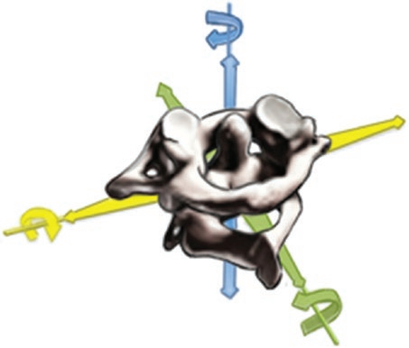
Fig .1.26 Cartesian coordinate system for analyzing CVJ motions

Most of biomechanical information concerning the CVJ has been derived from the experimental method known as Flexibility Testing. It uses, in vitro, cadaveric spinal segments of two or more vertebrae that have been deprived of muscle tissue, leaving the ligaments and the bone structures intact. Torsional forces (bending moments), lateral forces, or combined loads are applied to the spinal segments, and the spinal movement thus obtained are then misurated [⁴⁵]. Analysis of load-deformation responses reveals parameters such as stiffness, flexibility, range of motion, rotation, translation, neutral zones, elastic zones, and axes of rotation. These biomechanical parameters are different and unique for each single spinal segment and are sensitive indices of spinal instability. The information obtained through the flexibility test “in vitro” represents the total contributions provided by bone joints and the ligamentous apparatus between each motion segment.Several parameters can be calculated from the load-deformation curve. Flexibility represents the amount of deformation in response to a unit load[^{46,47}]. Stiffness is the opposite of flexibility. It is the amount of resistance to a unit increment of displacement in the specimen. Range of motion (ROM) is defined as the displacement between the neutral or resting position of the motion segment and the limit of its physiological motion. The neutral position is defined as the posture where minimal joint stresses occur and where minimal muscular effort is required to maintain the spatial orientation. This neutral position is best approximated by the midpoint of the bilateral neutral zone (NZ) [⁴⁸]. The NZ is the portion of the ROM where the ligaments are lax and small forces produce large vertebral displacements. The elastic zones (EZ) is the steep portion of the load-deformation curve where the ligaments become stretched and stiffness increases, causing resistance to any further movement. The motion characteristics of the different levels of the CVJ are due to the geometry of the vertebrae and skull base, the shapes of the joints, and the arrangements of the ligaments. Neither the C0-C1 nor the C1-C2 joints have an intervertebral disc. The spherical shape (concave-convex) of C0-C1 joint allows slightly more flexion and extension than the other levels of the cervical spine, although these are quite rigid in axial rotation and lateral bending. The biconvex articular surfaces of the C1-C2 joints allow wide rotation of C1 around the dens. The atlantoaxial motion segment is the most flexible of the entire spine with respect to axial rotation, allowing a bilateral ROM of 80° or more. More than half of all cervical axial rotations occur at the atlantoaxial motion segment. Both C0-C1 and C1-C2 allow less lateral bending than the subaxial cervical motion segments, which average approximately 8° unilaterally[ ⁴⁴](Fig1.27 a,b ).

a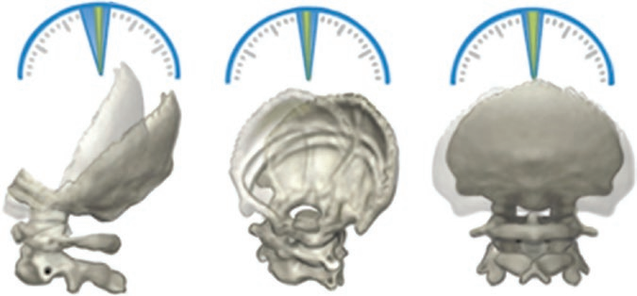
C0-C1 Flexion-Extension C0-C1 Axial Rotation C0-C1 Lateral Bending
Fig .1.27 a Representation of angular motions at occipitoatlantal motion segments.

b 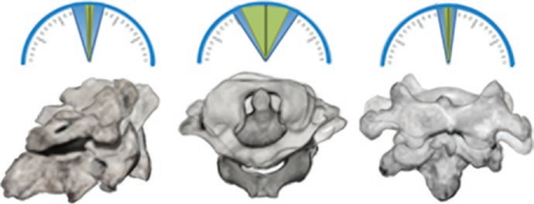
C1-C2 Flexion-Extension C1-C2 Axial Rotation C1-C2 Lateral Bending
Fig .1.27 b Representation of the normal angular motions at atlantoaxial motion segments

1.3.1.Of stable CVJ

The cervical spine’s range of motion is approximately 80°–90° of flexion, 70° of extension, 20°–45° of lateral flexion, and up to 90° of rotation on both sides. However, movement of the cervical spine is complex and movement into any range is not the simple sum of equal motion from one vertebra to the next. The occipitoatlantal junction contributes to 23°–24.5° of flexion/extension of the skull and the atlantoaxial joint provides an additional 10.1°–22.4° [⁴⁶]. At the occipitoatlantal junction, the abutment of the dens against the foramen magnum preventsupraphysiologicflexion, whereas odontoid contact with the tectorial membrane has been proposed to limitextension. The transverse ligament prevents pathological flexion of the atlantoaxial segment while extension is inhibited by the bony elements of the atlantoaxial jointfacets[^{45,46,47}].Physiological motion of the cervical spine can accomplish 90° of rotation from the midline. The atlantoaxial junction contributes to 25°–30°, at which point the motion occurs through subaxial segments. The bone facets of the atlantoaxial junction will permit up to 40° rotation before locking, contributing a major restriction to over rotation. The contralateral alar ligament and the ipsilateral transverse ligament also resist pathological rotation with support from the joint capsules of the occipitoatlantal and atlantoaxial junctions [^{48,49}]. The occipital condyles restrict lateral bending of the occipitoatlantal junction to 3.4°–5.5° in either direction. The atlantoaxial segment reaches 6.7° before the alar ligaments discourage further motion . Movement in the other planes of motion is minimal at the CVJ, including translation, distraction, and compression. Ligamentous as well as osseous structures are responsible for this stability. The transverse ligament, alar ligaments, and capsular joints resist anterior translation in the sagittal plane while the occipital condyles and the contact of the dens with the atlas and foramen magnum constitute bone barriers against posterior translation The capsular joints of the occipital condyles and the atlantoaxial zygapophyseal.[^{47,48,50,51}] joints resist compression. Distraction is not a physiological motion of the CVJ .

1.3.2.Of unstable CVJ

In response to trauma, the CVJ exhibits predictable patterns of failure based on the mechanism of injury [⁵²]. The most commonly encountered traumas occur during motor vehicle accidents, falls, diving accidents, and gunshot wounds . Fracture dislocation or occipitocervical dissociation at the CVJ is a leading cause of death in motor vehicle accidents. Multiple mechanisms have been proposed to explain these patterns, such as whiplash and flexion-distraction injury. Pathological flexion increases tension on the transverse ligament, resulting in failure of either the cruciate ligament or the odontoid waist. Failure of the tectorial membrane has also been associated with flexion in front-end motor vehicle collisions and may lead to dural tears. Isolated tectorial membrane failure contributes minor instability in flexion and extension [^{53,54,55,56}] .
Hyperextension may lead to fracture of the atlas at the posterior ring or fracture of the axis at the pars interarticularis or the odontoid. Shearing injury may occur to the ligaments of the anterior CVJ, including the alar ligaments, accessory atlantoaxial ligaments, cruciform ligament, and tectorial membranes. Supraphysiologic rotation at the atlantoaxial junction can predict, or even diagnose, alar ligament disruption. Traumatic compression of the CVJ commonly causes osseous pathology at the occipitoatlantal junction. Axial loading has been associated with burst fractures of the atlas and with occipital condyle fractures. When evaluating trauma to the CVJ, current guidelines recommend initial evaluation by CT followed by MRI to assess ligamentous injury ⁵⁷. T2-weighted MRI obtained within 72 h of injury is the preferred modality for diagnosing soft-tissue injury. After 72 h, decreased tissue edema may lead to overlooked ligamentous damage. Disruption of the ligamentous structures is sufficient to cause instability at the CVJ; additionally, these ligaments are irreparable once torn [⁵⁸]. The most critical ligaments to evaluate for stability in the CVJ are the transverse ligament of the cruciform complex, the alar ligaments, and the tectorial membrane [^{59,60}].
Failure of one alar ligament results in modest rotatory atlantoaxial instability. This instability is manifested as an increase in the C1-C2 ROM during the axial rotation, mostly through an increase in the NZ. The EZ and the flexibility, however, do not change significantly. The bilateral transection of the alar ligaments determines considerably more extensive alterations of C0-C1-C2 motion than unilateral alar ligament disruption. The NZ and ROM during axial rotation, lateral bending, and flexion-extension are all increased significantly. The pivotal function of the alar ligaments is to stabilize the spine during flexion and extension and to limit axial rotation and lateral bending. Failure of an alar ligament most likely occurs near the condylar insertion and introduces instability in rotation and an increase in flexion, extension, and lateral bending. Isolated rupture of the alar ligament is rare but has been associated with hyperflexion paired with rotation in all reported cases.Unfortunately, evaluation of the alar ligaments by MRI is complicated by their size and anatomical conformation[ ^{60,61}].

The transverse atlantal ligament is the thickest (1 cm) and strongest ligament of the entire spine. It is the most important stabilizer of the atlas, constraining C1 around the dens. Extremely high loads with anteriorly directed vectors at C1 are required to disrupt the transverse ligament. The mechanisms leading to failure of the transverse ligament have been extensively evaluated in vitro[⁶²]. The accessory ligaments at C1-C2 are relatively weak and stretch with ease after the transverse ligament is rendered incompetent. This feature has important clinical consequences. The transverse ligament tears suddenly with a principle of “all or nothing” because it is stiff and inelastic. This ligament does not tear partially or gradually. When torn, the transverse ligament is incapable of repair. Because the transverse ligament injury renders the articulation of C1 enormously unstable, stabilization (fusion) of the C1-C2 complex must be performed.Failure of the C1-C2 joint capsular ligament primarily slightly increases the ROM during axial rotation but has a minimal effect on lateral bending or flexion and extension[ ⁶³]. Most of the increase in ROM is due to an increase in the EZ. Injury to the capsular ligaments is an important mechanism associated with rotatory C1-C2 subluxation. Avulsion of a synovial joint capsule causes only a mild increase in rotatory motion; however, a rupture of the joint capsule warrants investigation of the more critical ligaments as it has been associated with the disruption of the transverse atlantal and alar ligaments.Experimental laboratory studies regarding atlas injuries indicate that burst fractures of the atlas outbreak derive from compressive injuries[^{64,56}]. Atlas burst fractures result in instability that is manifested as increases in the NZ and the ROM during flexion, extension, and lateral bending. In these studies, “in vitro” compressive injury caused a 90% increase in the flexion\extension NZ, a 44% increase in the flexion\extension ROM, and a 20% increase in lateral bending NZ and ROM. However, no significant changes were seen in axial rotation NZ or ROM.[⁶⁶]
Placement of instrumentation for stabilization of the craniocervical junction requires that fixation points and constructs be tailored to individual patient anatomy and that pathological movements be controlled. The latter are usually composed of some combinatio of anteroposterior translation, axial, sagittal, and coronal plane translation, as well as vertical translation (cranial settling).
Bicortical placement of occipital screws is preferred. The pullout strength of bicortical screws has been noted to be 50% greater than that of unicortical screws; the pullout strength of unicortical screws is similar to that of 18-gauge wire. Screw location is equally important, as screws placed in the midline demonstrate greater insertional torque and greater pullout strength than screws placed more laterally. 4 Despite the fact that longer screws may often be placed in the suboccipital region, 3.5-mm titanium screws longer than 7 mm typically break before pulling out,suggesting that the use of larger-diameter screws should be considered when possible. Also, though shorter, laterally placed occipital screws may o̥ffer less resistance to pullout, and constructs incorporating multiple laterally placed screws may perform equivalently to those with midline screws. There does not appear to be an advantage to the use of constrained (locking) screws in the suboccipital region. [⁶⁷]
Incorporation of posterior occiput–C1 transarticular screws into larger constructs, though theoretically possible, has not been described. Goel and Laheri discussed the use of a C2 pars screw in isolation or in combination with a C1 lateral mass screw for the fixation of the cervicalend of the occipitocervical plate/rod.[⁶⁸].Goel and Laheri first described the use of screws in the lateral mass of C1 in 1988, reporting excellent outcomes in 30 patients with atlantoaxial subluxation. Landmarks for the placement of C1 lateral mass screws have been studied in detail With an entry point above the C2 nerve root (or the space available after the sectioning of the C2 root), at the junction of the C1 posterior arch and the midpoint of the posteroinferior part of the C1 lateral mass, screws can be placed with a medial angulation of 9.8 to 21.6° and a superior angulation of 17.8 to 28.8°, depending on the individual patient’s anatomy. Although C2 nerve root irritation as a result of C1 lateral mass placement inferior to the C1 arch is a potential complication, the incidence has been reported to be 12%, and the symptoms are temporary Screws placed into the pars interarticularis of C2 have gained wide acceptance as caudal anchors for occipito cervical instrumentation constructs. Following a modification of the technique used in the subaxial cervical spine, screws are placed using an entry point at the junction of the inferior border of the lamina and the midpoint of the inferior facet process of C2, with a trajectory 15° medial and parallel to the superior surface of the lateral mass (usually 35° superior) in the sagittal plane.[⁶⁸]. Bicortical screw purchase is not used. In case of a deep vertebral artery groove, screw length may be shortened to avoid injury. A minor, though potentially useful variant of this technique employs a less medially directed trajectory, similar to that of a C1–C2 transarticular screw, through the lateral mass of C2. This technique allows the later conversion to a C1–C2 transarticular screw, if necessary.
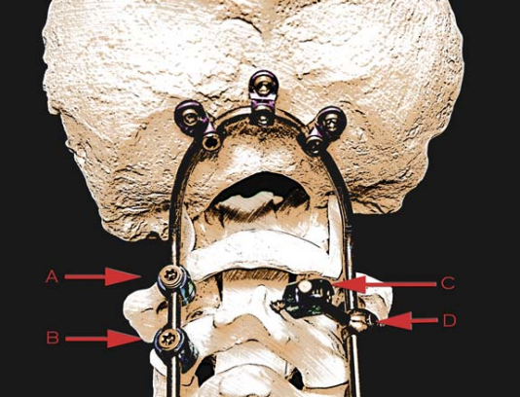
Fig. 1.28 Potential À xation points at C1 and C2. C1 lateral mass screw ( A), C1–C2 transarticular screw ( B), C2 intralaminar screw (C), and o̦ set connector between the C2 intralaminar screw and the longitudinal element ( D). Note that the head of the C1 lateral mass screw falls very near the bend in the longitudinal element.

C2 pedicle screw is defined as one that passes through the C2 pedicle along its axis and terminates within the body of C2 ( Fig.1.28 ). Usually with the assistance of intraoperative neuronavigation techniques, the pedicle of C2 may be cannulated using a 39° medial trajectory parallel to the inferior end plate in the sagittal plane. Radiographic analyses have shown that 91% of C2 pedicles could accept a screw at least 4 mm in diameter[.⁶⁹]. C2 pedicle screws have been shown to have significantly higher resistance to pullout than C2 pars interarticularis screws and to provide caudal fixation equivalent to C1–C2 transarticular screws in finite element modeling. C2 pars interarticularis and pedicle screws are readily incorporated into longer occipitocervical constructs. Goel and Kulkarni placed the screw into the spinolaminar junction, incorporating the thickness of the spinous process. Wright described the technique for placement of intralaminar C2 screws. Using an entry point at the base of the C2 lamina, crossing screws may be placed into the cancellous bone between the cortices ( Fig.1.29 ). Gorek et al. demonstrated equivalent ROM reduction in C1–C2 constructs anchored by intralaminar C2 screws and C2 pedicular screw.
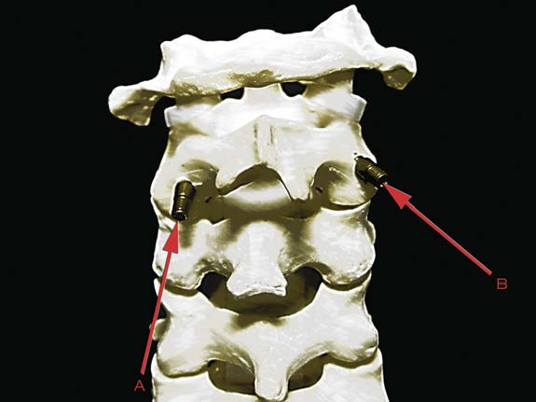
Fig. 1.29 C2 pars interarticular ( A) and pedicle screws ( B). Note the more cranial entry point and more medial trajectory of the C2 pedicle screw.

When employed as a salvage technique, C2 lamina screws exhibit a pullout strength at least equivalent, if not superior, to screws placed into the pars interarticularis of C2. Though incorporation into longer constructs generally requires three-plane rod bending or special o̥ffset connectors, C2 lamina screws may be particularly useful in situations where the C2 lateral mass or pedicle is attenuated. The placement of the screw at the spinolaminar junction as described by Goel and Kulkarni appears to provide more stability to the construct than the placement of the screw in the lamina. C1–C2 transarticular screws were initially developed for stabilization of the C1–C2 segment and are excellent, even when placed unilaterally, at controlling axial plane rotation at that location. Bilateral or even unilateral C1–C2 transarticular screw fixation, in combination with intraspinous bone graft wiring, has been shown to be adequate in the majority of patients for the treatment of isolated atlantoaxial instability. Screws are placed using an entry point at the level of the inferior border of the C2 lamina and the midpoint of the ipsilateral pars interarticularis of C2. Using intraoperative fluoroscopy or neuronavigation, a pilot hole is drilled with a slightly medial trajectory through the lateral mass of C2, across the C1–C2 articulation, and into the lateral mass of C1, using the anterior arch of C1 as a fluoroscopic target. Not all patients possess anatomy at C1–C2 suitable for the placement of transarticular screws. Potential impediments to placement include irreducible deformity and the presence of a deep vertebral artery groove. Radiographic analyses by Lehman et al. showed that C1–C2 transarticular screws could be placed in 113 of 120 (94%) sides examined in patients without rheumatoid arthritis. Abou Madawi et al. examined the vertebral artery groove in 50 anatomical specimens, noting that in 11 (22%) the groove was deep enough to preclude the placement of C1–C2 transarticular screw on at least one side. 32 This correlates well with the study of Paramore et al., in which it was postulated, based on CT data, that 18% to 23% of patients may not be suitable for C1–C2 transarticular screw placement on at least one side.[⁷⁰]
1.3.4.Sagittal balance at CVJ

Sagittal alignment of the CVJ has evolved in synchrony with our progression from quadruped to biped posture[⁷¹]. The center of gravity of the head in quadrupeds is located quite anterior of the CVJ due to the development of the splanchnocranium, the horizontality of the base of the skull, and the posterior position of the occipital condyles, so that the occipito-atlantal (OC1) joint alignment is almost vertical. In primates and even more markedly in humans, basicranial flexion is observed in the sphenoid, with the clivus then forming an angle with the anterior part of the base of the skull. This process, probably related to the development of the cerebral hemi spheres and the reduction of the facial mass, coincides with the anterior migration of the occipital condyles, which has the effect of considerably reducing the bending moment of the center of gravity of the head. In humans, the OC1 articulation is horizontal, and the center of gravity of the head vertical line passes right in front of the dens. Head posture is governed by the ability to maintain horizontal gaze, hearing, equilibrium, naso respirational function, and even psychological condition .

1.4.Radiological Investigations

The workup of a patient to determine the presence of instability; radiographs are especially preferred in young children, to avoid the higher radiation dose of computed tomography (CT) screening. Radiographs should include a lateral view of the skull showing the spine, and the anterior open-mouth view and oblique views of the cervical spine. Supplementary views such as a Towne’s view and the anteroposterior projection into the foramen magnum are done as necessary. High-resolution CT with reformatted two-dimensional (2D) or preferably three dimensional (3D) imaging is done to clearly define the relationship and the dimensions of the CVJ. These studies can be done with the patient in the flexed and extended position to demonstrate the biomechanics. Magnetic resonance imaging (MRI) with the CVJ in flexed and extended positions defines the relationship of the bony abnormalities with the neural structures and helps with identifying any associated neural abnormalities. However, the bony anatomy must be precisely outlined with CT and 3D CT scanning(Fig.1.30,31). With all imaging techniques, dynamic studies are necessary to assess the stability and the osseous-angular relationships to the neural structures. This provides information regarding the reducibility as well as the position of fixation and fusion, should this be essential. The effects of cervical traction must be documented not only with plain radiographs but also with intraoperative CT or MRI to confirm the relief of neural compromise and restoration of relationships of the CVJ. Any unexplained neurologic symptom or sign that cannot be accounted for by the previously mentioned studies requires vascular imaging with magnetic resonance angiography (MRA) or CT angiography (CTA), both of which can identify obstruction to the vertebral vessels with rotated head position or as a result of deformity and malignancy. In individuals with atlas assimilation and basilar invagination, a rotary subluxation of the atlas on the axis vertebrae can result in vertebral artery distortion, and occlusions are common. Imaging to determine the position of these critical vessels and the possible distortion that may occur with position change should be done prior to surgical treatment.

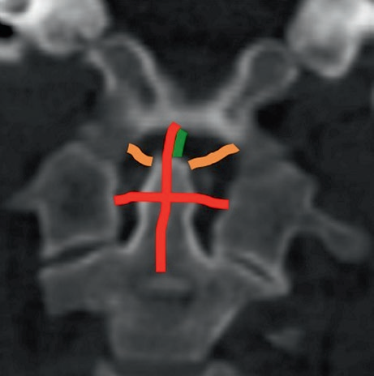
Fig .1.30 CT scan with 1 mm slice thickness, coronal oblique MPR reconstruction: the orange lines represent the alar ligaments, the green line the apical ligament, and the red line the cruciate ligament. The odontoid process is visualized in its long axis.
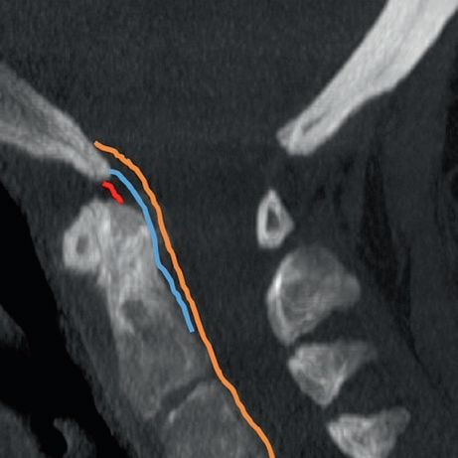
Fig.1 31 CT scan with 1 mm slice thickness, sagittal MIP reconstruction: the orange line represents the tectorial membrane, the blue line the superior and inferior crus of the cruciate ligament, and the red line the apical ligament.

Radiological assessment of the stability of the CCJ, the evaluation should focus on tectorial membrane, odontoid process, and anterior margin of foramen magnum about the flexion-extension movements related to the occipital-atlas joint; and transverse and alar ligaments about the rotational movements related to the atlas-axial joint. All these elements need to be evaluated by high-field magnetic resonance imaging (MRI) with thin slice acquisitions.The surgical approach to the CCJ, especially with the developing of modern less invasive techniques, requires a clear and accurate preoperative assessment of the anatomy of this area, including bones, ligaments, and also vascular structures[⁷¹]. In this scenario, role of imaging is not only to recognize the lesion or the anatomical variants but also to support the surgeon in the choice of the correct treatment planning.

1.5.References
1. Sensenig EC. The development of the occipital and cervical segments and their associated structures in human embryos. Contrib Embryol 1957;36:141–152.
2. O’Rahilly R, Gardner E. The initial appearance of ossiÀ cation in staged human embryos. Am J Anat 1972;134(3):291–301.
3. Wilting J, Kurz H, Brand-Saberi B, et al. Kinetics and differentiation of somite cells forming the vertebral column: studies on human and chick embryos. Anat Embryol (Berl) 1994;190(6):573–581.
4. O’Rahilly R, Müller F Human Embryology and Teratology. New York: John Wiley & Sons; 1996.
5. O’Rahilly R, Müller F. Developmental Stages in Human Embryos, Including a Survey of the Carnegie Collection: A. Embryos of the First Three Weeks (Stages 1 to 9). Washing
ton, DC: Carnegie Institute of Washington; 1987 .
6. Huang R, Zhi Q, Patel K, Wilting J, Christ B. Contribution of single somites to the skeleton and muscles of the occipital and cervical regions in avian embryos. Anat Embryol (Berl) 2000;202(5):375–383 .
7. Noback CR. The developmental anatomy of the human osseous skeleton during the embryonic, fetal and circumnatal periods. Anat Rec 1944;88:91–125.
8. Weinstein SL. The Pediatric Spine: Principles and Practice. New York: Raven Press; 1994.
9. Verbout AJ. The development of the vertebral column. Adv Anat Embryol Cell Biol 1985;90:1–122.
10. Hensinger RN. Osseous anomalies of the craniovertebral junction. Spine 1986;11(4):323–333
11.Nagib MG, Maxwell RE, Chou SN. Klippel-Feil syndrome in children: clinical features and management. Childs Nerv Syst 1985;1(5):255–263
12.Suchomel P, Choutka O. Reconstruction of upper cervical spine and craniovertebral junction. Berlin: Springer-Verlag; 2011.
13.Rhoton AL Jr, De Oliveira E. Anatomical basis of surgical approaches to the region of the foramen magnum. In: Bambakidis C, Dickman A, Spetzler F, et al., editors. Surgery of the craniovertebral junction. 2nd ed. New York: Thieme; 2013. p. 13–51.
14.Lang J. The cranio-cervical junction—anatomy. In: Voth D, Glees P, editors. Diseases in the cranio-cervical junction. Anatomical and pathological aspects and detailed clinical accounts. Berlin, New York: Gruyter; 1987. p. 27–61.
15.Rhoton AL Jr. The foramen magnum. Neurosurgery. 2000;47(3 Suppl):S155–93.
16.Heller JG, Pedlow FX Jr, Gill SS. Anatomy of the cervical spine. In: Clark CR, editor. The cervical spine. 4th ed. Philadelphia: Lippincott Williams & Wilkins; 2005. p. 3–36.
17.Rhoton AL Jr. The far-lateral approach and its transcondylar, supracondylar, and paracondylar extensions. Neurosurgery. 2000;47(3 Suppl):S195–209.
18.Rhoton AL Jr. Jugular foramen. Neurosurgery. 2000;47(3 Suppl):S267–85.
19. Jhawar SS, Nunez M, Pacca P, et al. Craniovertebral junction 360°: a combined microscopic and endoscopic anatomical study. J Craniovertebr Junct Spine. 2016;7(4):204–16.
20.Pimenta NJ, Gusmão SS, Kehrli P. Posterior atlanto-occipital and atlanto-axial area and its surgical interest. Arq Neuropsiquiatr. 2014;72(10):788–92.
21.Youssef AS, Uribe JS, Ramos E, et al. Interfascial technique for vertebral artery exposure in the suboccipital triangle: the road map. Neurosurgery. 2010;67(2 Suppl Operative):355–61.
22.Dean NA, Mitchell BS. Anatomic relation between the nuchal ligament (ligamentum nuchae) and the spinal dura mater in the craniocervical region. Clin Anat. 2002;15(3):182–5
23.Tubbs RS, Hallock JD, Radcliff V, et al. Ligaments of the craniocervical junction. J Neurosurg Spine. 2011;14:697–709.
24.Reis CV, Yagmurlu K, Elhadi AM, et al. The anterolateral limit of the occipital lobe: an anatomical and imaging study. J Neurol Surg B Skull Base. 2016;77(6):491–8.
25.Mussi AC, Matushita H, Andrade FG, et al. Surgical approaches to IV ventricle—anatomical study. Childs Nerv Syst. 2015;31(10):1807–14.
26.Matsushima K, Yagmurlu K, Kohno M, et al. Anatomy and approaches along the cerebellarbrainstem fissures. J Neurosurg. 2016;124(1):248–63.
27.Wanibuchi M, Fukushima T, Zenga F, et al. Simple identification of the third segment of the extracranial vertebral artery by extreme lateral inferior transcondylartranstubercular exposure (ELITE). Acta Neurochir. 2009;151(11):1499–503.
28.Cacciola F, Phalke U, Goel A. Vertebral artery in relationship to C1-C2 vertebrae: an anatomical study. Neurol India. 2004;52(2):178–84.
29.Overland J, Hodge JC, Breik O, et al. Surgical anatomy of the spinal accessory nerve: review of the literature and case report of a rare anatomical variant. J Laryngol Otol. 2016;130(10):969–72.
30.Lloyd S. Accessory nerve: anatomy and surgical identification. J Laryngol Otol. 2007;121(12):1118–25.
31.Verma R, Kumar S, Rai AM, et al. The anatomical perspective of human occipital condyle in relation to the hypoglossal canal, condylar canal, and jugular foramen and its surgical significance. J Craniovertebr Junct Spine. 2016;7(4):243–9.
32.George B, Blanquet A, Alves O. Surgical exposure of the vertebral artery. In: Spetzler RF, editor. Operative techniques in neurosurgery. Philadelphia: W.B. Saunders; 2001. p. 182–94.
33.Argenson C, Francke JP, Sylla S, et al. The vertebral arteries (segment V1 and V2). Anat Clin. 1980;2:29–41.
34.George B. Exposure of the upper cervical vertebral artery. In: Dickman CA, Spetzler RF, Sonntag VKH, editors. Surgery of the craniovertebral junction. New York: Thieme; 1998. p. 545–67.
35. Goel A, Laheri VK. Plate and screw À xation for atlanto-axial subluxation. Acta Neurochir (Wien) 1994;129:47–53.
36. Naderi S, Korman E, Citak G, et al. Morphometric analysis of human occipital condyle. Clin Neurol Neurosurg 2005;107(3):191–199
37. Papagelopoulos PJ, Currier BL, Stone J, et al. Biomechanical evaluation of occipital À xation. J Spinal Disord 2000;13(4):336–344 .
38,Caglar YS, Torun F, Pait TG, Hogue W, Bozkurt M, Ozgen S. Biomechanical comparison of inside-outside screws, cables, and regular screws, using a sawbone model. Neurosurg Rev 2005;28(1):53–58 .
39. Grob D. Transarticular screw À xation for atlanto-occipital dislocation. Spine (Phila Pa 1976) 2001;26(6):703–707 .
40. Harms J, Melcher RP. Posterior C1–C2 fusion with polyaxial screw and rod À xation. Spine (Phila Pa 1976) 2001; 26(22):2467–2471.
41. Cacciola F, Phalke U, Goel A. Vertebral artery in relationship to C1–C2 vertebrae: an anatomical study. Neurol India 2004;52(2):178–184 .
- Panjabi MM, Whithe AA III, Brand RA Jr. A note on defining body parts configurations. J Biomech. 1974;7(4):385–7.
43.Goel VK. Three–dimensional motion behavior of the human spine—a question of terminology. J Biomech Eng. 1987;109(4):353–5.
44.White AA III, Panjabi MM. Clinical biomechanics of the spine. 2nd ed. Philadelphia, PA: JB Lippincott; 1974.
45.Panjabi MM. Biomechanical evaluation of spinal fixation devices: a conceptual framework. Spine. 1988;13(10):1129–34.
46.Dickman CA, Crawford NR, Tominga T, et al. Morphology and kinematics of the baboon upper cervical spine. A model of the atlantoaxial complex. Spine. 1994;19(22):2518–23.
47.Panjabi MM, Dvorák J, Duranceau J, et al. Three–dimensional movements of the upper cervical spine. Spine. 1988;13(7):726–30.
48.Panjabi MM. The stabilizing system of the spine. Part II. Neutral zone and instability hypothesis. J Spinal Disord. 1992;5(4):390–6.
1992;5(4):390–6.
49.Dvorak J, Panjabi MM, Novotny JE, Antinnes JA. In vivo flexion/extension of the normal cervical spine. J Orthop Res. 1991;9:828–34.
50.Dvorak J, Schneider E, Saldinger P, Rahn B. Biomechanics of the craniocervical region: the alar and transverse ligaments. J Orthop Res. 1988;6:452–61.
51.Ghanayem AJ, Zdeblich TA, Dvorak J. Functional anatomy of joints, ligaments, and discs. In: Clark CR, Ducker TB, Cervical Spine Research Society Editorial Committee, editors. The cervical spine. 3rd ed. Philadelphia: Lippincott-Raven; 1998. p. 45–52.
52.Dvorak J, Panjabi MM. Functional anatomy of the alar ligaments. Spine (Phila Pa 1976). 1987;12:183–9.
53.Iai H, Moriya H, Goto S, Takahashi K, Yamagata M, Tamaki T. Three-dimensional motion analysis of the upper cervical spine during axial rotation. Spine (Phila Pa 1976). 1993;18:2388–92.
54.Fielding JW, Gv C, Lawsing JF III, Hohl M. Tears of the transverse ligament of the atlas. A clinical and biomechanical study. J Bone Joint Surg Am. 1974;56:1683–91.
55.Wolfla CE. Anatomical, biomechanical, and practical considerations in posterior occipitocervical instrumentation. Spine J. 2006;6(6 Suppl):225S–32S.
56.Debernardi A, D’Aliberti G, Talamonti G, Villa F, Piparo M, Collice M. The craniovertebral junction area and the role of the ligaments and membranes. Neurosurgery. 2011;68:291–301.
57.Clark CR, White AA III. Fractures of the dens. A multicenter study. J Bone Joint Surg Am. 1985;67:1340–8.
58.Krakenes J, Kaale BR, Moen G, Nordli H, Gilhus NE, Rorvik J. MRI of the tectorial and posterior atlanto-occipital membranes in the late stage of whiplash injury. Neuroradiology. 2003;45:585–91.
59.Harris MB, Duval MJ, Davis JA Jr, Bernini PM. Anatomical and roentgenographic features of atlanto occipital instability. J Spinal Disord. 1993;6:5–10.
60 Oda T, Panjabi MM, Crisco JJ III, Oxland TR. Multidirectional instabilities of experimental burst fractures of the atlas. Spine (Phila Pa 1976). 1992;17:1285–90.
61.Werne S. Studies in spontaneous atlas dislocation. Acta Orthop Scand Suppl. 1957;23:1–150.
62. Como JJ, Diaz JJ, Dunham CM, Chiu WC, Duane TM, Capella JM, et al. Practice management guidelines for identification of cervical spine injuries following trauma: update from the eastern Association for the Surgery of Trauma Practice Management Guidelines Committee. J Trauma. 2009;67:651–9.
63.Fielding JW, Cochran GVB, Lawsing JF III, et al. Tears of the transverse ligament of the atlas. A clinical and biomechanical study. J Bone Joint Surg Am. 1974;56(8):1683–91.

64.Crisco JJ, Oda T, Panjabi MM, et al. Transection of the C1–C2 joint capsular ligaments in the cadaveric spine. Spine. 1991;16(10 suppl):474–9.
65.Panjabi MM, Oda T, Crisco JJ, et al. Experimental study of atlas injuries. I. Biomechanical analysis of their mechanisms and fracture patterns. Spine. 1991;16(10 suppl):460–5.
66. Oda T, Panjabi MM, Crisco JJ III, et al. Experimental study of atlas injuries. II. Relevance to clinical diagnosis and treatment. Spine. 1991;16(10 suppl):466–73.
67. Anderson PA, Oza AL, Puschak TJ, Sasso R. Biomechanics of occipitocervical À xation. Spine (Phila Pa 1976) 2006;31(7):755–761.
68.Goel A, Laheri VK. Plate and screw À xation for atlanto-axial subluxation. Acta Neurochir (Wien) 1994;129:47–53 .
69. Resnick DK, Lapsiwala S, Trost GR. Anatomic suitability of the C1–C2 complex for pedicle screw À xation. Spine (Phila Pa 1976) 2002;27(14):1494–1498.
70. Paramore CG, Dickman CA, Sonntag VK. The anatomical suitability of the C1–2 complex for transarticular screw fixation. J Neurosurg 1996;85(2):221–224 .
71. White AA III, Panjabi MM. The clinical biomechanics of the occipitoatlantoaxial complex. Orthop Clin North Am. 1978;9(4):867–78. (no abstract available).

